**Introduction to OKR**

**Introduction to OKR Systems**

Objectives and Key Results (OKR) is a goal-setting framework that helps organizations, teams, and individuals align their efforts and measure progress effectively. Originally popularized by companies like Intel and Google, OKRs provide a structured way to define ambitious goals (Objectives) and track measurable outcomes (Key Results). This system ensures that everyone within an organization is working toward common, high-impact goals while maintaining transparency and accountability.

**Core Components of an OKR System**

The OKR framework consists of several key components that work together to align goals, measure progress, and drive execution. These components ensure that objectives are well-defined, progress is quantifiable, and teams remain focused on achieving meaningful results.

**1. Objectives – Defining the “What”**

Objectives represent the **desired outcome** an individual, team, or organization aims to achieve. They provide **direction and purpose**, ensuring that efforts are focused on high-impact priorities.

**Key characteristics of effective Objectives:**

* **Aspirational & Ambitious** – Objectives should push individuals and teams beyond their comfort zones, encouraging innovation and growth.
* **Clear & Actionable** – They must be specific and easy to understand, avoiding vague or overly broad statements.
* **Aligned with Strategy** – Objectives should support the broader vision and goals of the organization.
* **Qualitative** – Unlike Key Results, Objectives are not necessarily measurable but should be inspirational and motivating.

**Example of a Strong Objective:**  
✅ *Improve customer experience and satisfaction across all digital platforms.*

**2. Key Results (KRs) – Measuring Success**

Key Results define **how success is measured** for a given objective. They are **quantifiable, specific, and time-bound**, providing a clear way to track progress.

**Key characteristics of effective Key Results:**

* **Measurable & Objective** – They must have a **clear metric** that indicates success or failure.
* **Outcome-Oriented** – Instead of tracking activities, KRs should measure **results and impact**.
* **Challenging Yet Achievable** – They should stretch teams to perform at their best but remain realistic.
* **Limited in Number** – Typically, each Objective should have **2–5 Key Results** to maintain focus.

**Example of Strong Key Results (for the Objective above):**  
 *-Increase Net Promoter Score (NPS) from 50 to 70 by the end of Q2.  
 -Reduce average customer support response time from 24 hours to 6 hours.  
 -Increase customer retention rate from 80% to 90%.*

**3. Initiatives – Bridging Strategy and Execution**

Initiatives are the **specific projects, tasks, or activities** undertaken to achieve the Key Results. While Objectives and Key Results define **what needs to be achieved**, Initiatives focus on **how to achieve it**.

**Key characteristics of effective Initiatives:**

* **Actionable & Tactical** – They outline clear steps teams need to take.
* **Directly Linked to Key Results** – Every Initiative should contribute to achieving a Key Result.
* **Flexible & Adaptable** – Unlike OKRs, Initiatives may evolve as priorities shift.

**Example of Initiatives (for the Key Result: Reduce customer support response time from 24 hours to 6 hours):**  
*-Implement a live chat feature on the website.  
-Hire and train three additional support agents.  
-Automate common inquiries with AI-powered responses****.***

**4. Alignment & Transparency – Ensuring Organizational Focus**

OKRs are most effective when they align **across different levels** of an organization. This ensures that every individual and team is working toward **common strategic goals**, fostering a culture of collaboration and shared accountability.

**Key principles of Alignment & Transparency:**

* **Top-Down & Bottom-Up Approach** – While leadership sets high-level objectives, teams should have input in defining their own OKRs to ensure ownership and engagement.
* **Cascading Goals** – Organizational OKRs should align with departmental and team OKRs to drive a unified effort.
* **Visibility Across Teams** – OKRs are typically shared openly within an organization to promote transparency and accountability.

**Example of Alignment:**

* **Company-Level Objective:** Expand global market presence.
  + **Marketing Team Objective:** Increase brand awareness in key international markets.
    - **Key Result:** Grow website traffic from international users by 40%.

**5. Cadence & Review Process – Tracking Progress and Iterating**

A strong OKR system includes a **regular cadence of tracking, reviewing, and adjusting goals** to ensure continuous progress. Unlike static goal-setting frameworks, OKRs encourage frequent reflection and adaptability.

**Key aspects of an effective OKR review process:**

* **Quarterly OKR Cycles** – Most organizations set and review OKRs every **3 months**, ensuring they remain relevant and responsive to change.
* **Regular Check-Ins** – Weekly or bi-weekly team meetings help track progress, identify roadblocks, and adjust strategies.
* **Scoring & Reflection** – At the end of each OKR cycle, teams review performance, score their Key Results (on a scale of 0.0 to 1.0 or 0% to 100%), and extract lessons for improvement.
* **Continuous Iteration** – OKRs should evolve based on feedback, insights, and shifting business priorities.

**Mock up Brief**

Below mockup integrates key features from various OKR (Objectives and Key Results) systems, serving as a foundational guide for the design and development team.

The goal is to create a user-friendly, intuitive, and feature-rich OKR system that simplifies goal-setting, tracking, and performance evaluation.

By combining the best elements from existing OKR platforms, this design aims to enhance usability, improve team collaboration, and provide a seamless experience for users at all levels.

The mockup will help ensure that the final product is both comprehensive and easy to navigate, ultimately driving better goal alignment and productivity within organizations."

**1. Configuration/Admin Menu and Options**

- Add a **Configure** menu to the home page left menu bar, providing administrators with a centralized hub to manage and customize various settings of the OKR system.

Under Configure Menu add the following options

1. **General** – Used to configure **General Settings** i.e. **Company Details**, **Features**, **Progress reporting**, **Notifications**, **Templates**, **tags and Security and Privacy** as shown below

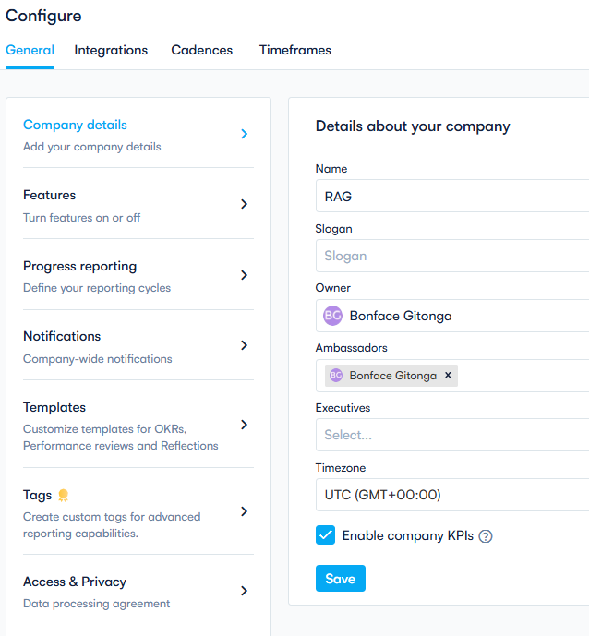

-**Features Configurations** –Add or remove various OKR features

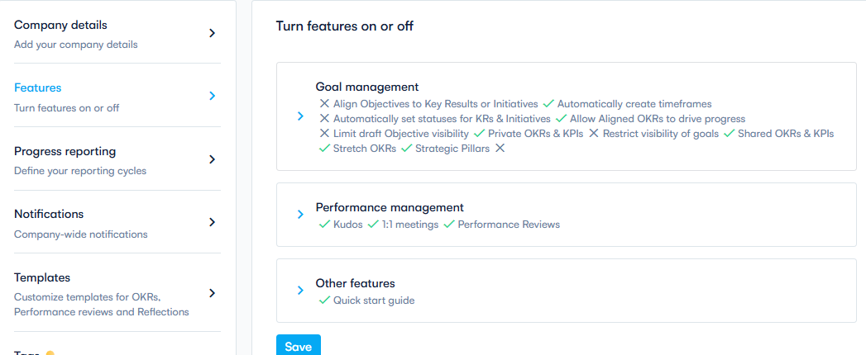

**-Progress reporting Users**- configure reports cycles and frequency

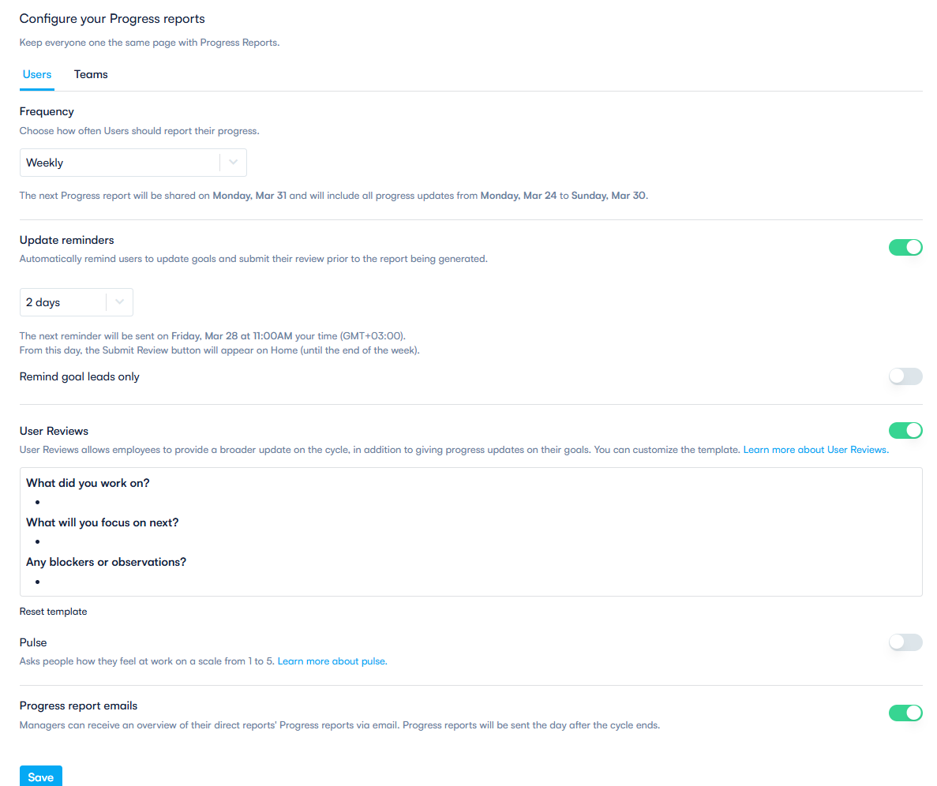

-**Aggregated reports** –configure automated Email reports and frequency

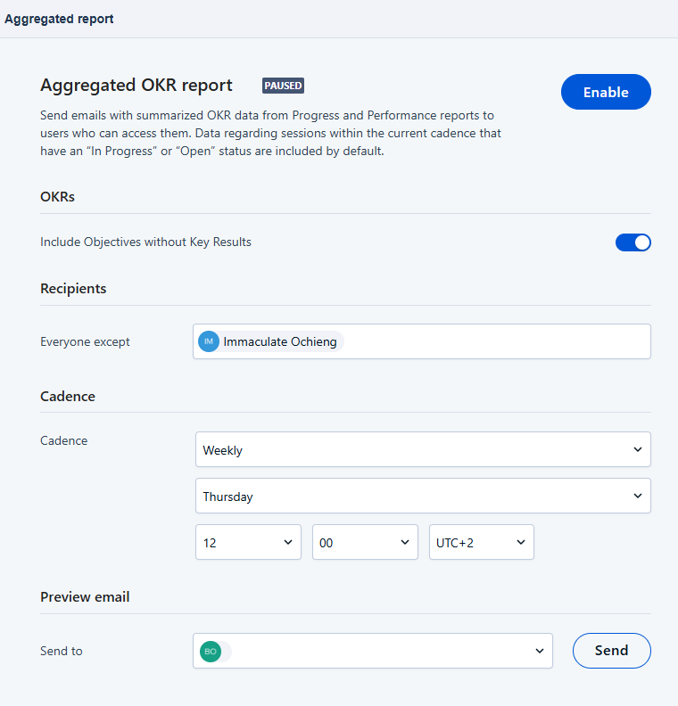

-Aggregated reports sample

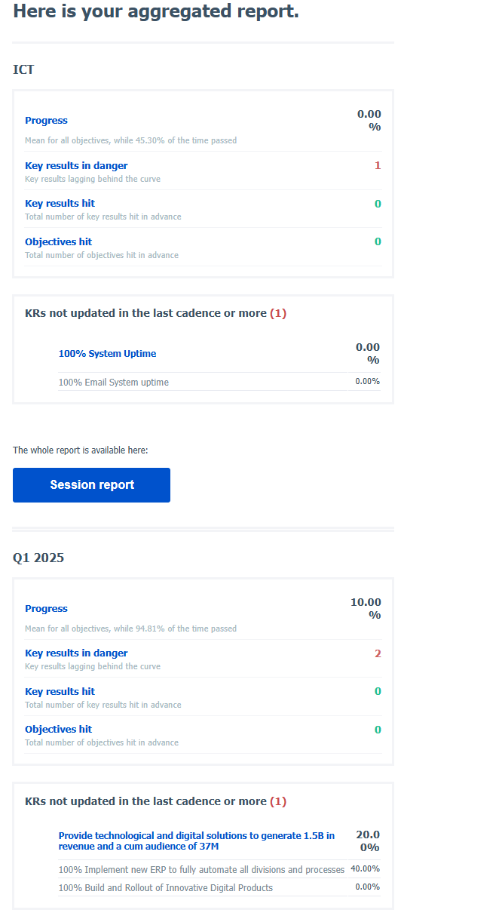

-**Account Notifications** –Create and Manage user notifications

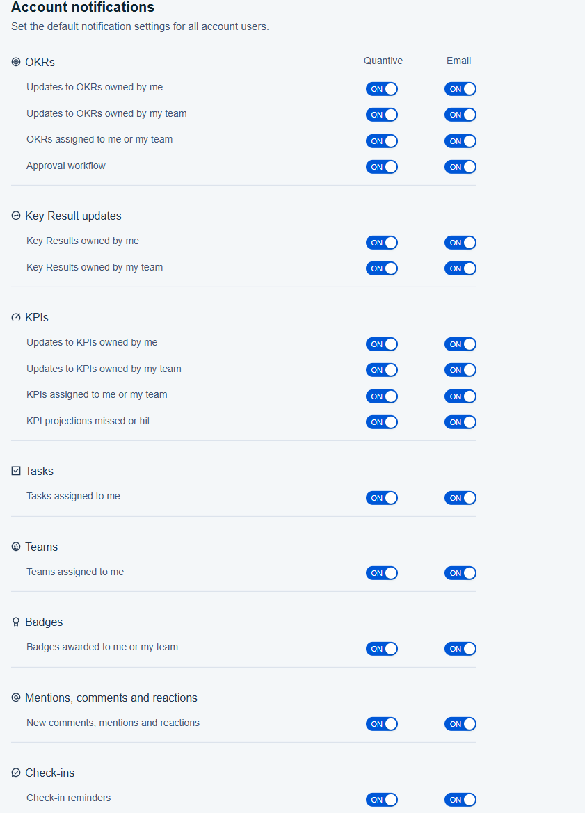

-**OKR templates** –Customise templates for OKRs and Performance reviews

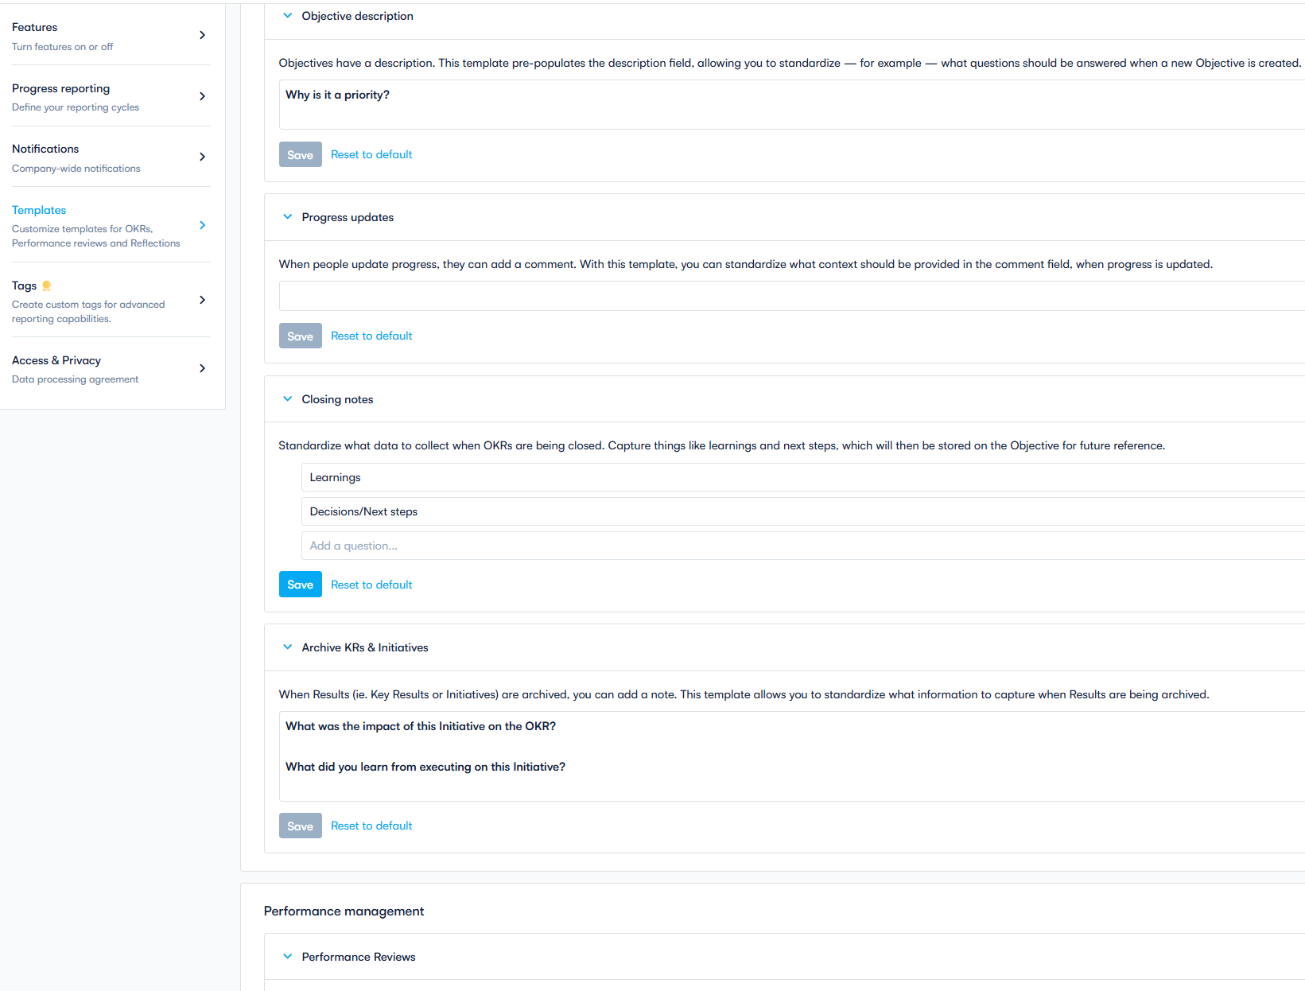

-**Tags** for creating and managing tags. Tags will be used advanced reporting and search filters

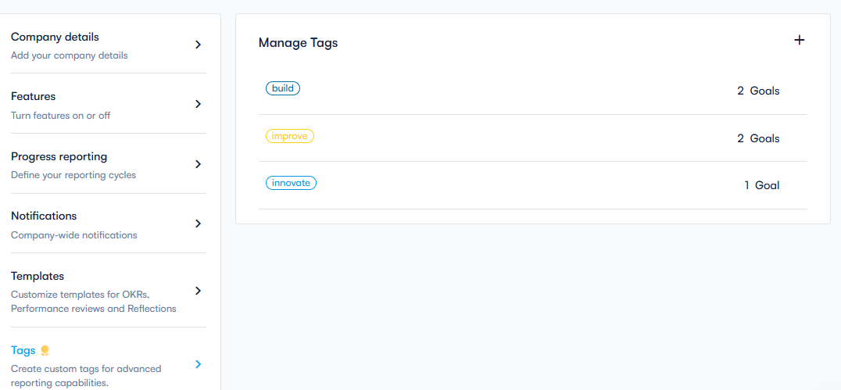

-**Status Management -**Configuration-Status Create various coloured status to be used to monitor progress on Key results and objectives

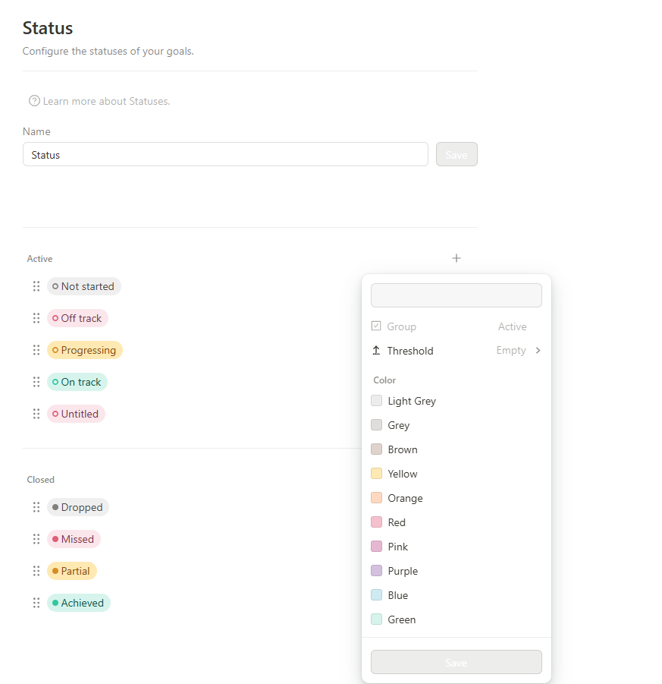

**-Team management**

Under Configuration-Settings - Team

-Feature will be used to create and edit teams, note below screenshot within **configurations team** you can manage teams or departments of your organization. It should be possible to create new teams and assign a color, an icon and a description to each team. We should be able to map your organizational structure by arranging teams via drag and drop and assigning parent teams, where needed. For each team, it is possible to add new members directly and also assign an owner.

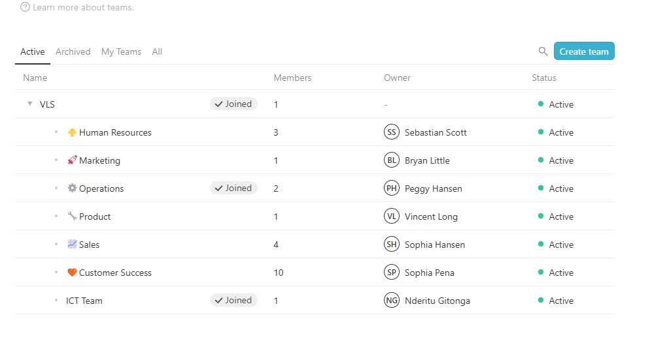

-Adding a new team sample, Provide an option to choose a colour and Icon as shown below

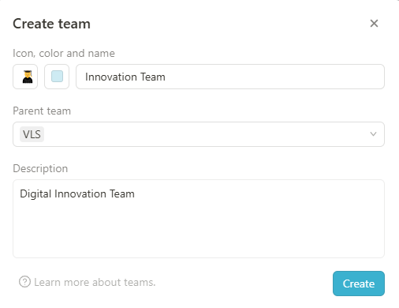

**-Users and permission’s Menu**

Under Configuration-Settings - Team

Add New Users –Under configuration-Settings-Users Menuwhich will be used to create and manage users and also to create different access groups to assign permissions

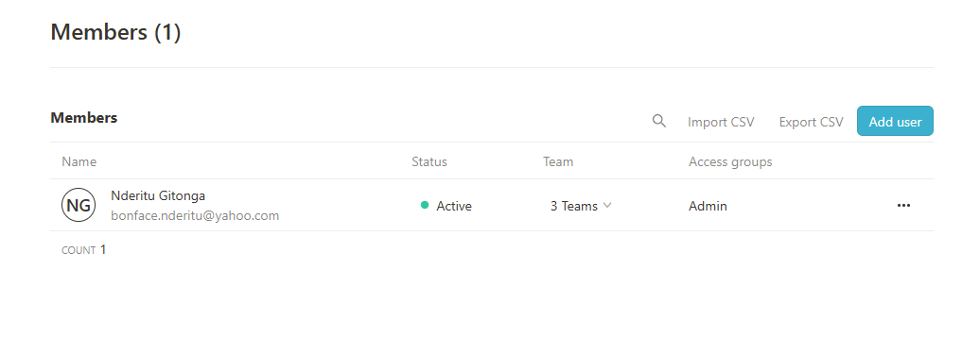

Users

-To add a new users click on add users

-Enter the user’s details:

* Name-First and Last name
* Email: User Official email
* Language:
* Access Groups- Rights that a user will have
* Manager:
* Checkbox to **Send Invitation by Email**
* Save

-**Access groups and Permissions** -Managing permissions and access groups, as an admin, you can manage the rights of all employees and for different features or specific access groups under Configurations- Settings –Access Groups

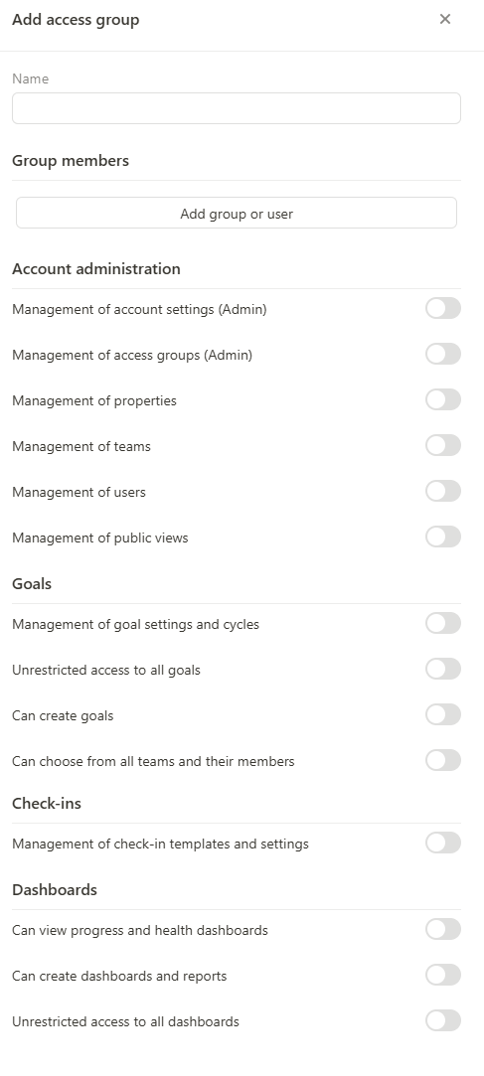

-Under Access group ensure we add rights for editing and creating OKRS to ensure users can only update Key results and initiatives to which they have been assigned

## ****Under access groups a new custom group****

* Click **Create New Access Group** to set up a custom access level.
* Enter a name (e.g., **OKR Contributors**).
* Add a description specifying the group’s role and permissions.

### Configure Permissions for OKR Editing and Creation

Under **Objectives & Key Results Permissions**, adjust the following settings:

* **Allow OKR creation** – Enable e.g. only for Admins, Team Leads, or designated Managers.
* **Disable OKR creation** – Restrict for general users to prevent unauthorized goal setting.

### Restrict Editing Rights to Assigned Key Results & Initiatives

Find the **Key Results & Initiatives Permissions** section. Set permissions as follows:

* **Allow Editing for Assigned Key Results** – Users can only update KRs assigned to them.
* **Allow Initiative Updates for Assigned Users** – Contributors can edit initiatives they own.
* **Restrict Editing for Unassigned OKRs** – Users cannot edit KRs or initiatives they are not linked to.
* **Prevent Deleting OKRs** – Only Admins or OKR Owners can remove objectives.

-Sample of **New custom group** to be created

**OKR Editing and Creation**

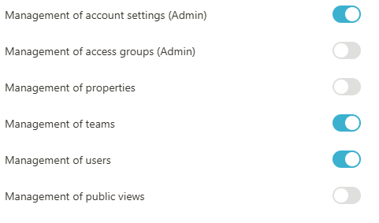

**Deleting Objectives and Key Results**

**Key Results and Initiatives Creation**

Allow OKR Creation: Admin & Managers

**Restrict Editing for Unassigned OKRs**

**Allow Initiative Updates for Assigned Users**

**Allow Editing for Assigned Key Results**

Disable OKR Creation: General Users

## 

**Prevent deleting of Key Results**

**Prevent deleting of Objectives**

-**Single** **sign on and LDAP** feature –Add Single Sign-On and LDAP authentication feature

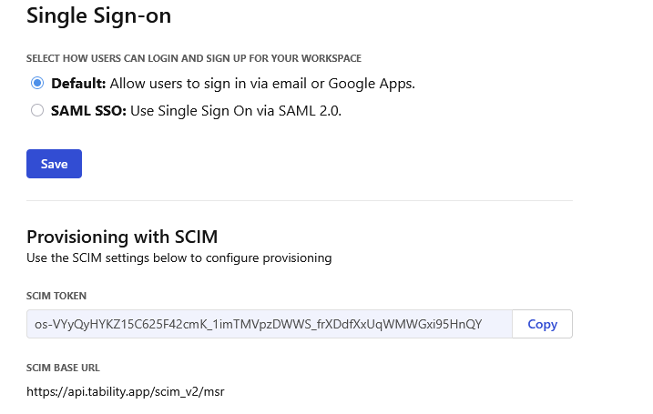

**LDAP Authentication Settings**

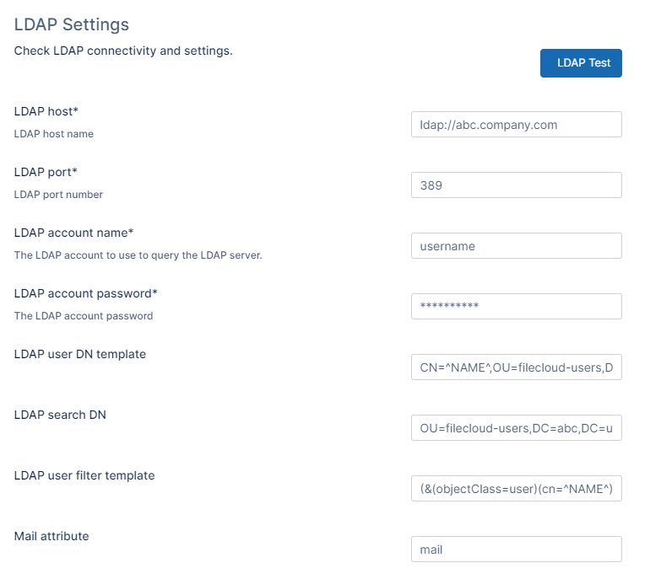

-**Integrations Menu**- Used to manage API’s and Third-party integrations

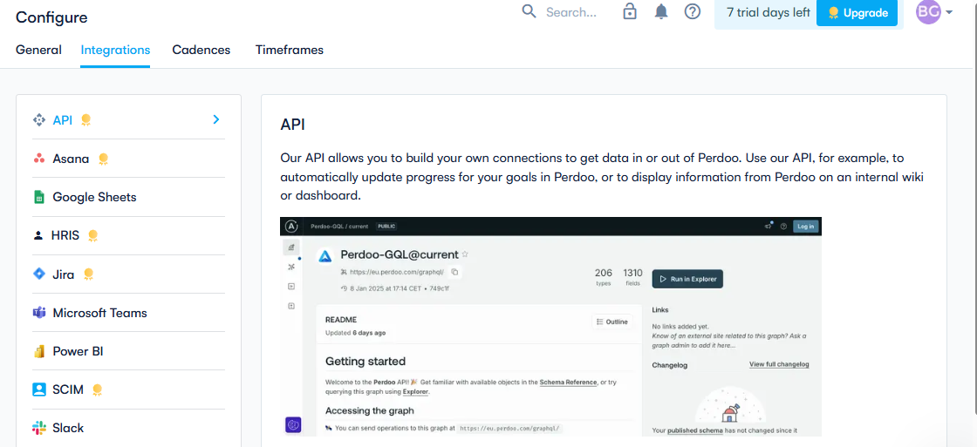

-**Cadencies Menu-**Under Configuration add Cadences menu as shown below, A cadence refers to the frequency with which you set and review goals, e.g. Annual, Quarterly, Monthly.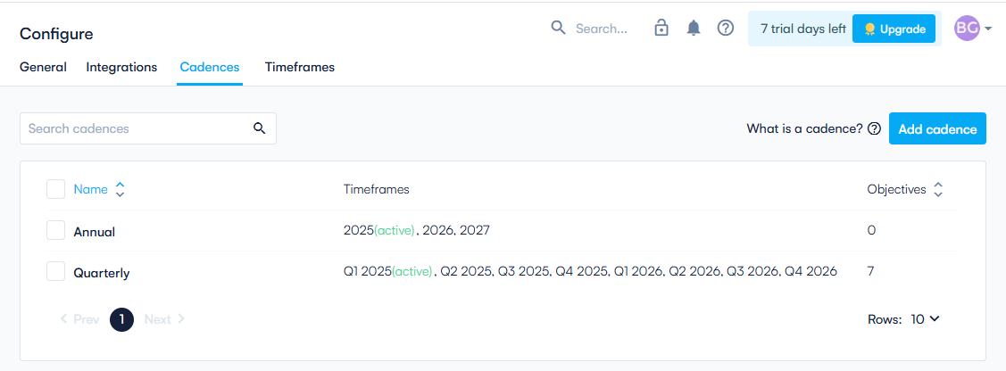

-Add Cadence view sample

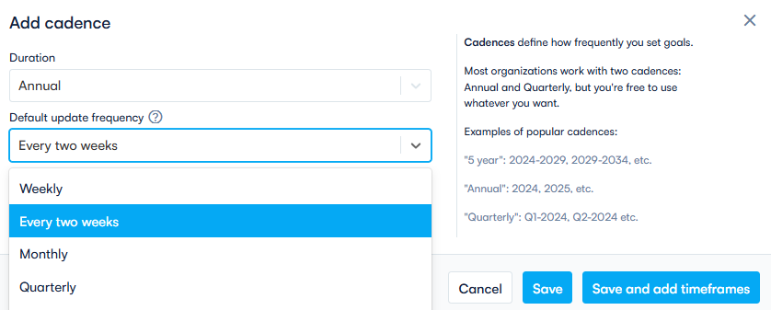

**-Timeframes Menu-**Under Configuration add Timeframes menu as shown below which will be used to create and manage timeframes/periods which the goals are created for, Note below sample where a user’s selects the Cadence Annual or Quarter, and enters the name for the period under review. Timeframes are date ranges within the defined cadence e.g. Q1 2025 (Jan 1, 2025 - Mar 31, 2025); Annual (Jan 1, 2025 - Dec 31, 2025).

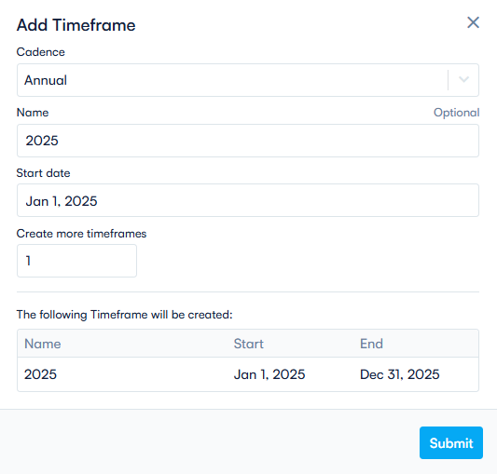

**2. Landing Page -** Intuitive and user-friendly sample home screen (We can edit the content during design)

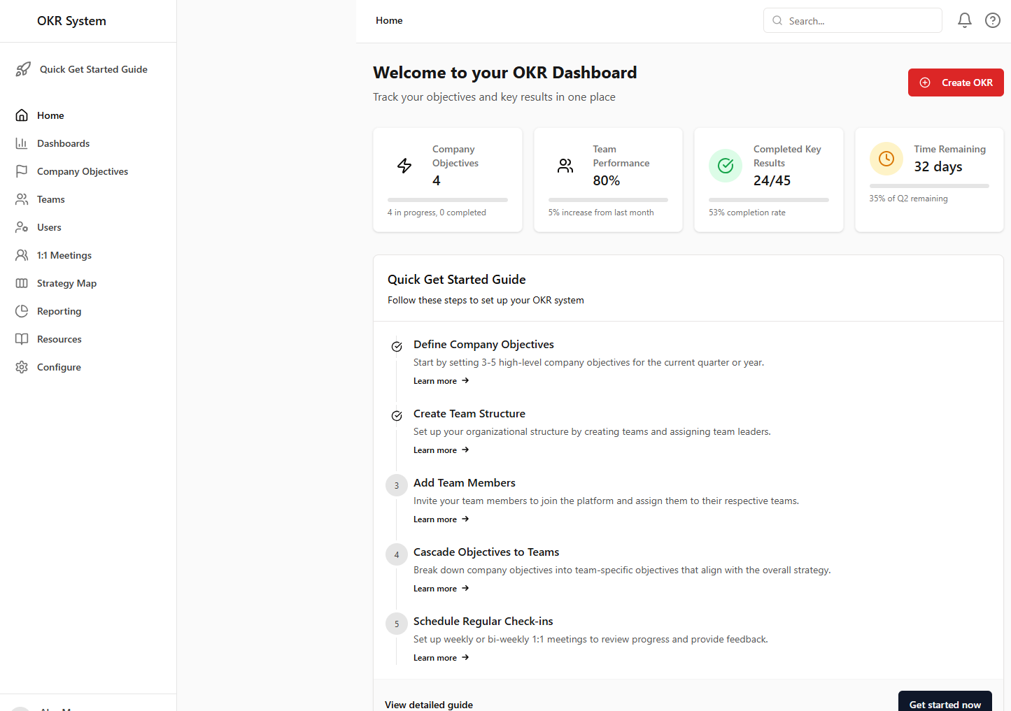

* 1. **Quick Get Started- Menu**

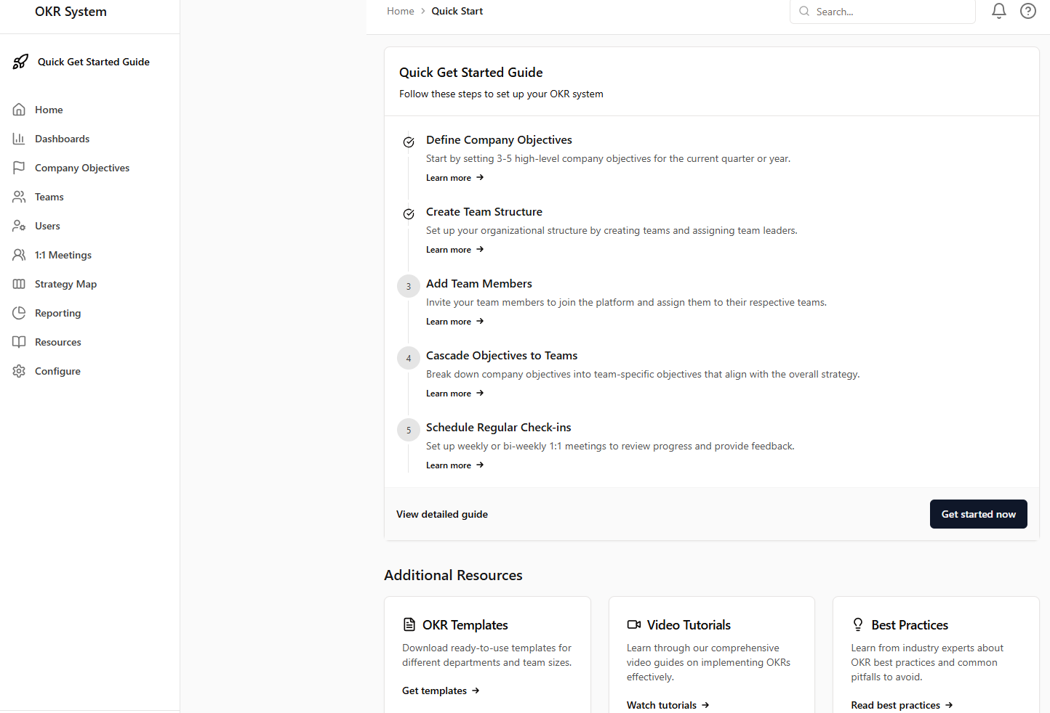

-Show the get started guide for the key sections and include templates, Video Tutorials and best practices guide

* 1. **Home Menu –** Will contain the mission and a detailed view of OKRs, Check-ins, Dashboard and members as shown below

**Mission Menu**

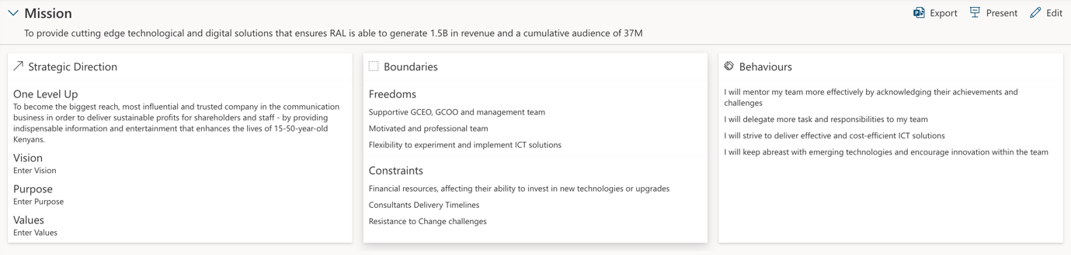

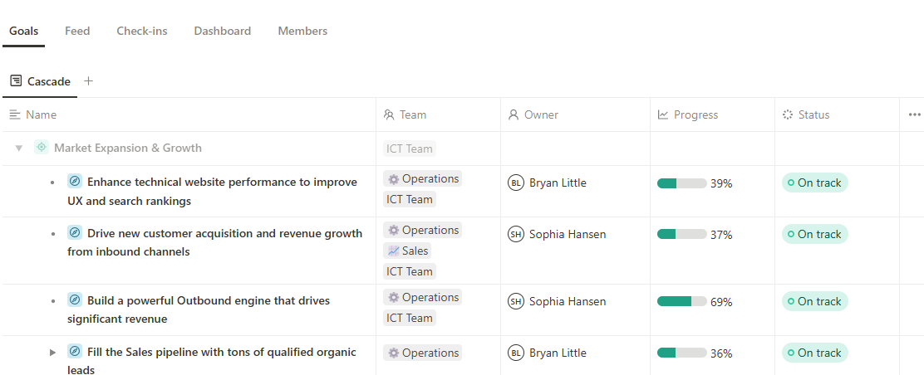

**Dashboard**

**OKRS**

**Check-ins**

* **Check-ins Tab**- Managers should be able to view all their teams’ check-ins

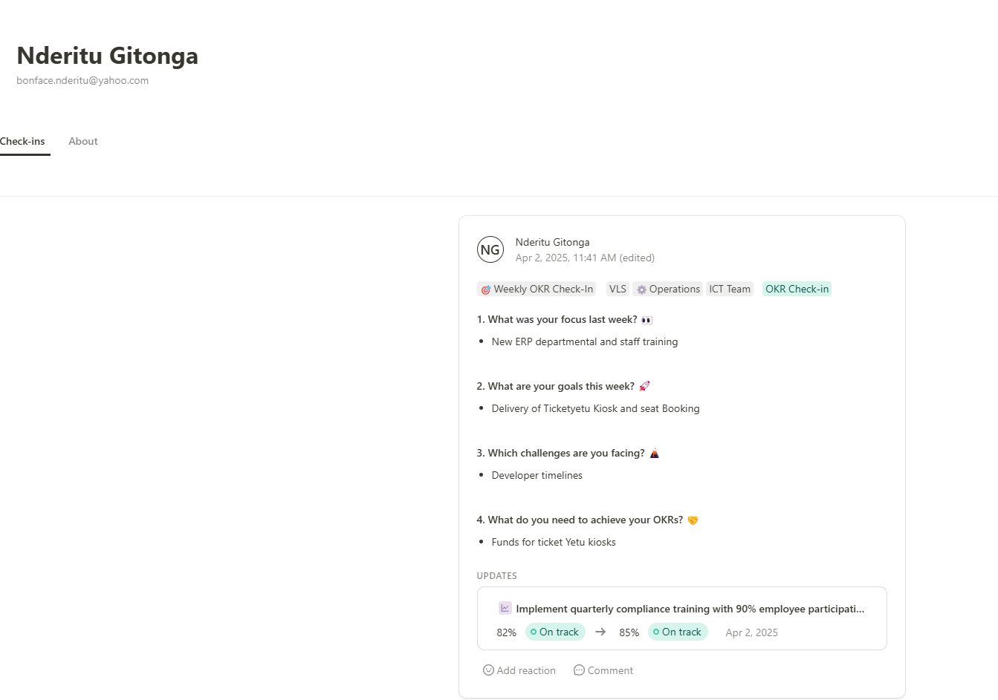

* **Dashboard Tab** Show –Teams Objectives, key results, Check-in and To-dos

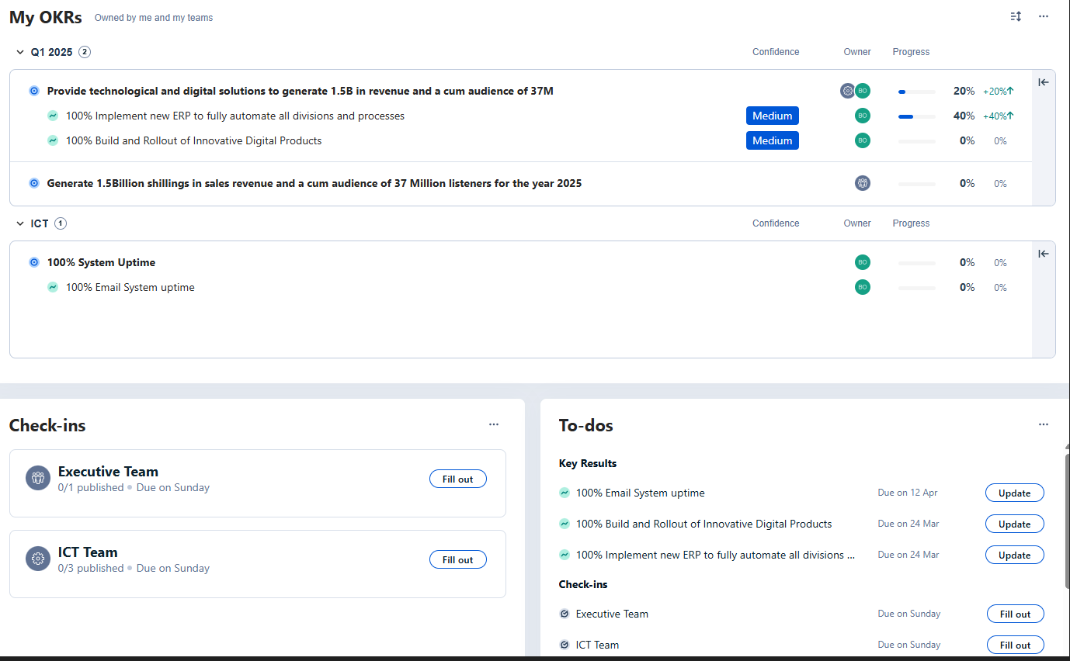

* **Members Tab** –Show the list of Users in that Team

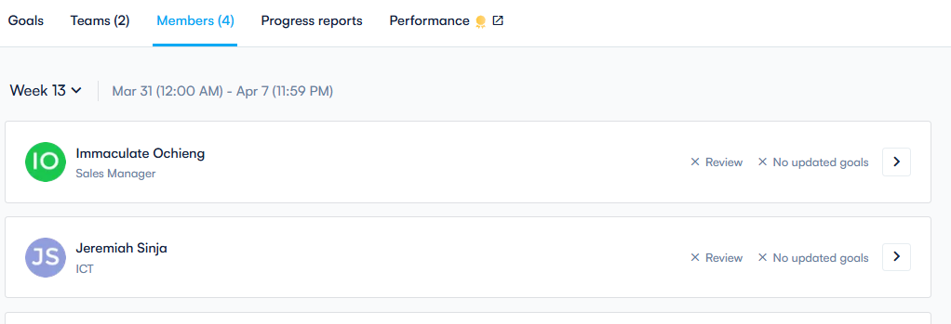

-If a user’s clicks on a **single users redirect** to review page when manager can see all OKRs and key results as shown below

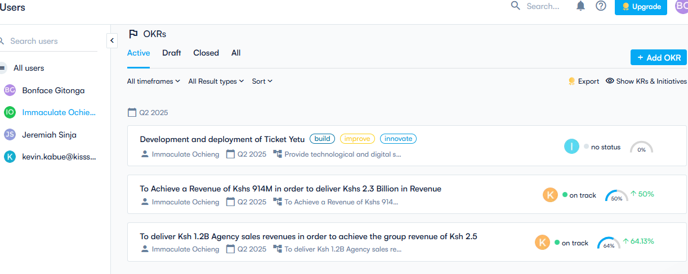

* 1. **Company Strategy Menu**

-Will be used to show a detailed view of the Company strategy and alignment to team’s objectives plus progress indicators.

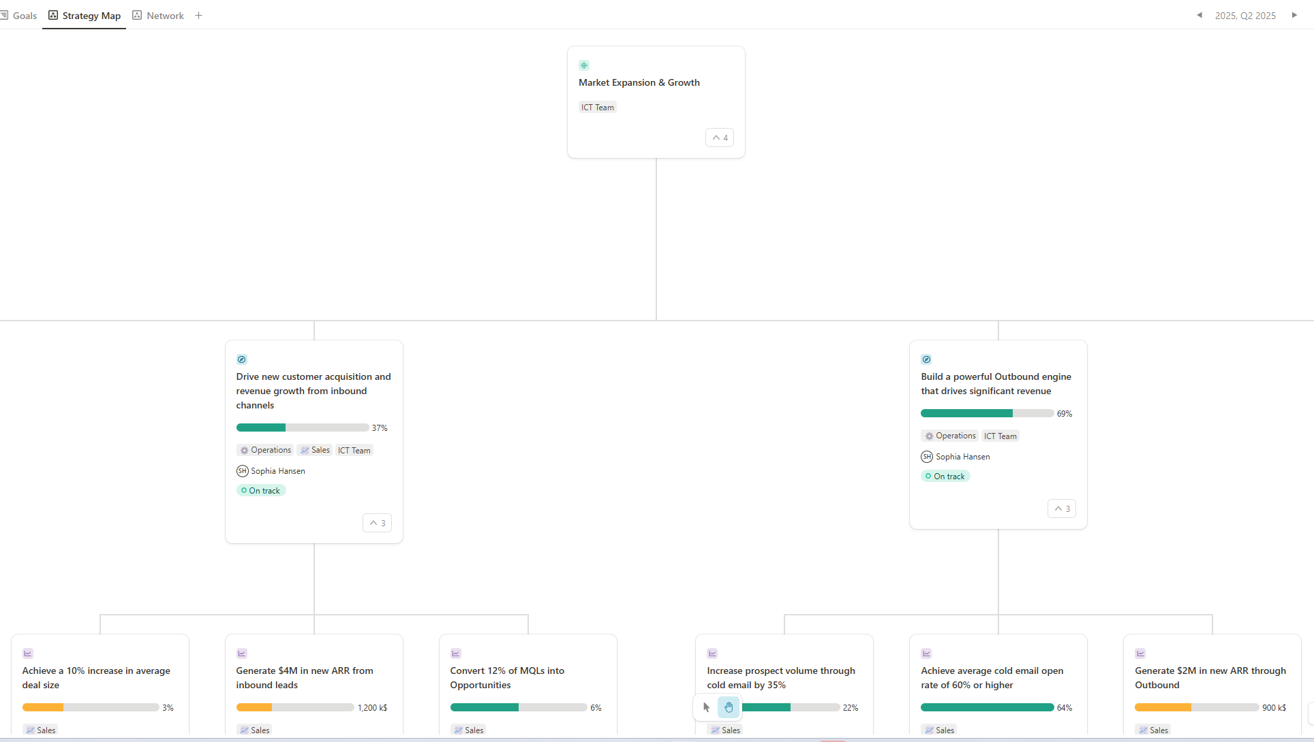

* **Below strategy map Each Teams Objective’s view**

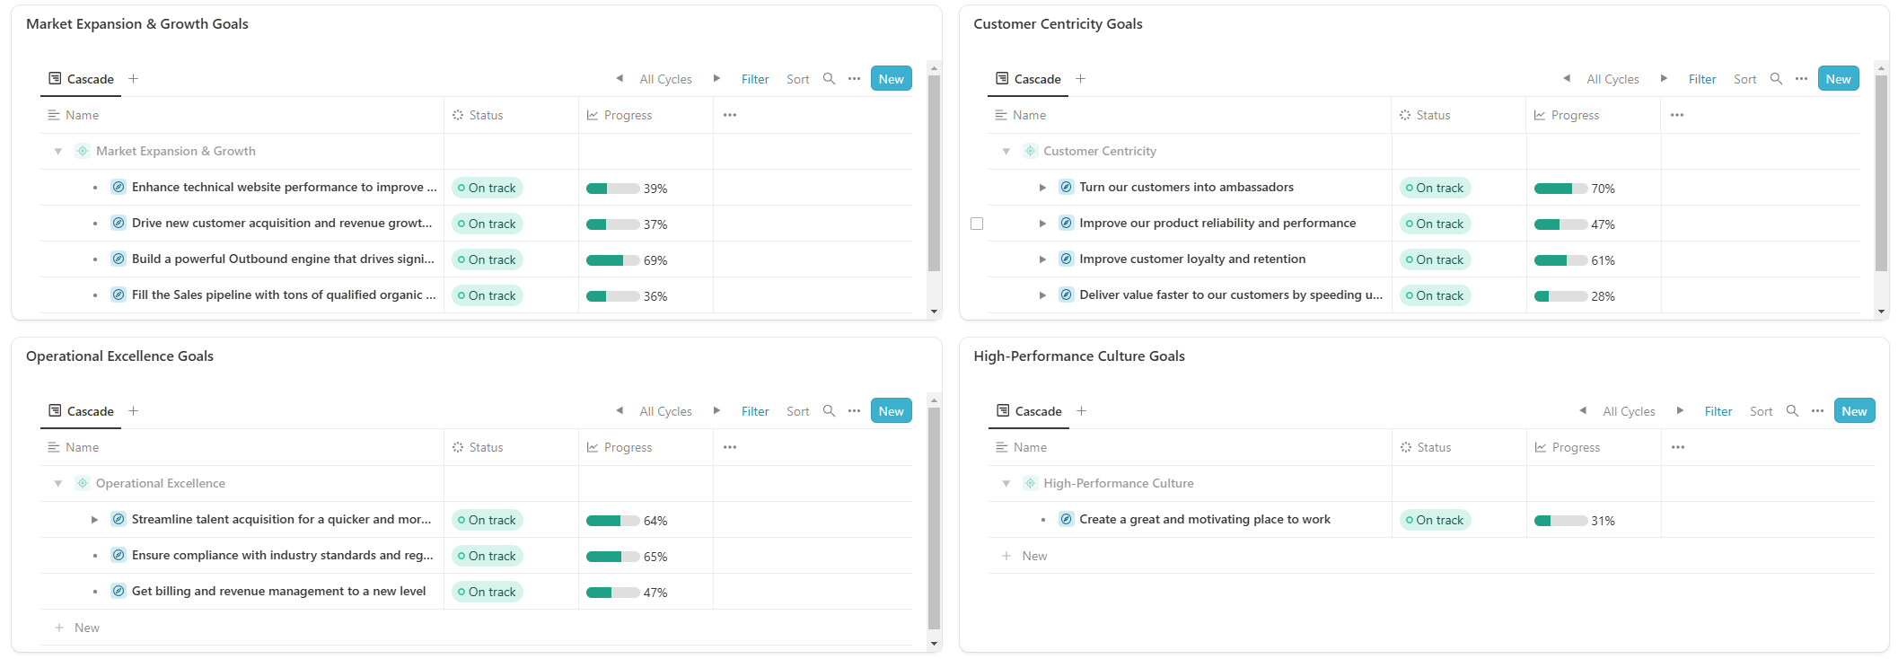

* **Below teams Objectives show Key Results Overview with below options**

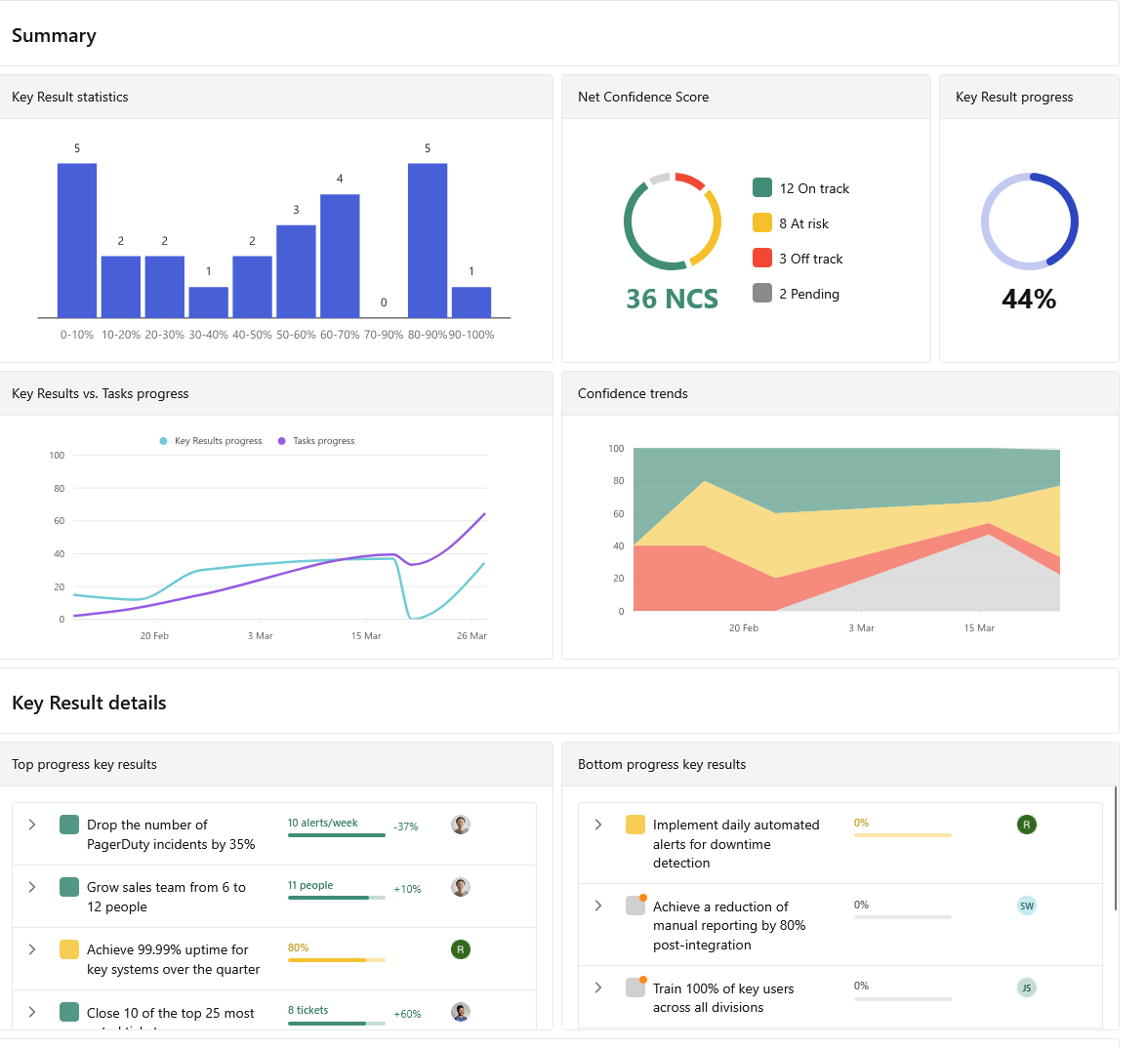

* **Below team objective show Key results show Insights/Activity Overview with below options**

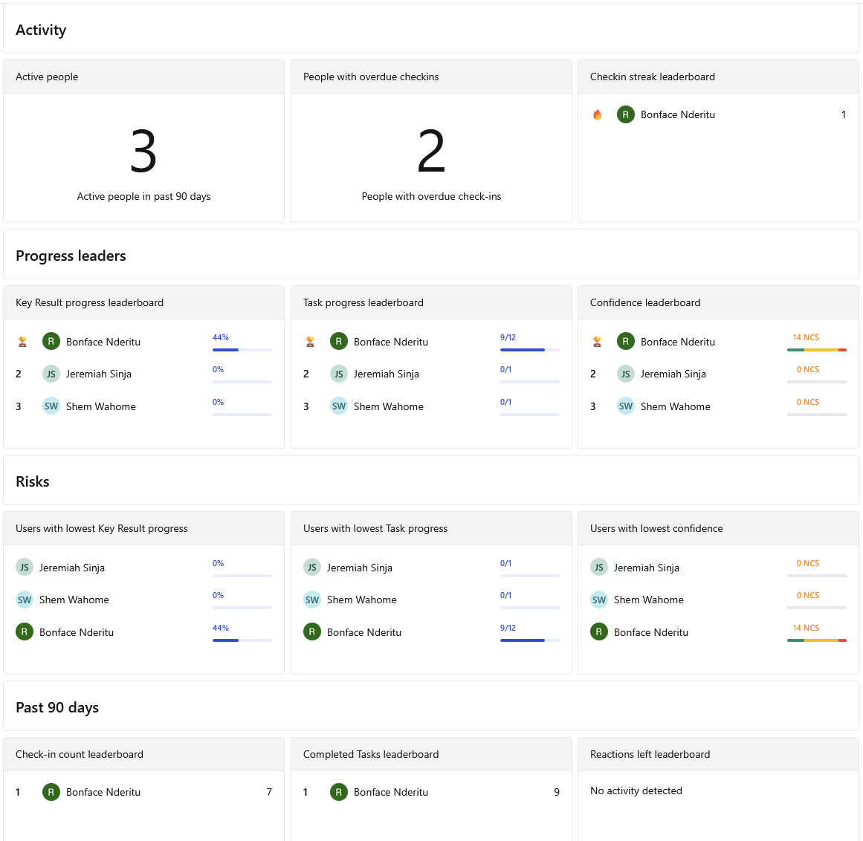

1. **Teams Menu**

-Team ManagementShow all the relevant teams and members

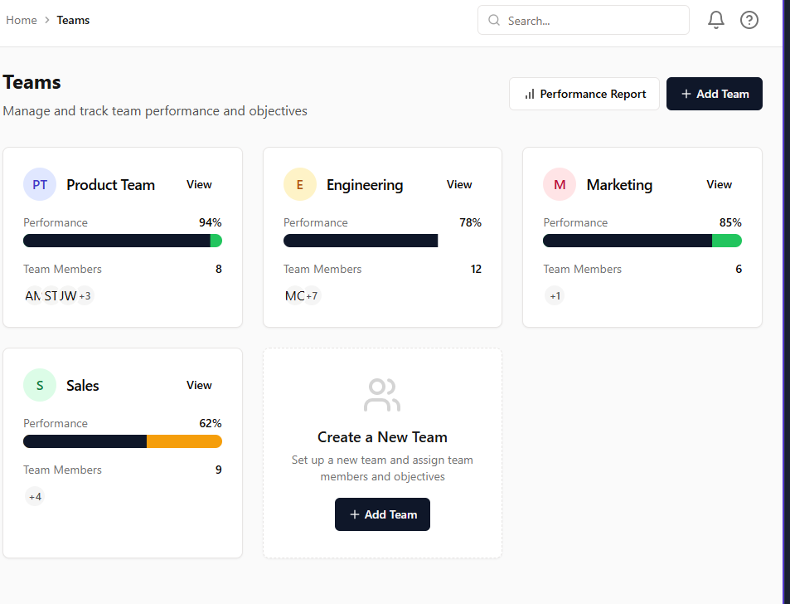

-if you go into teams menu view the members of the team

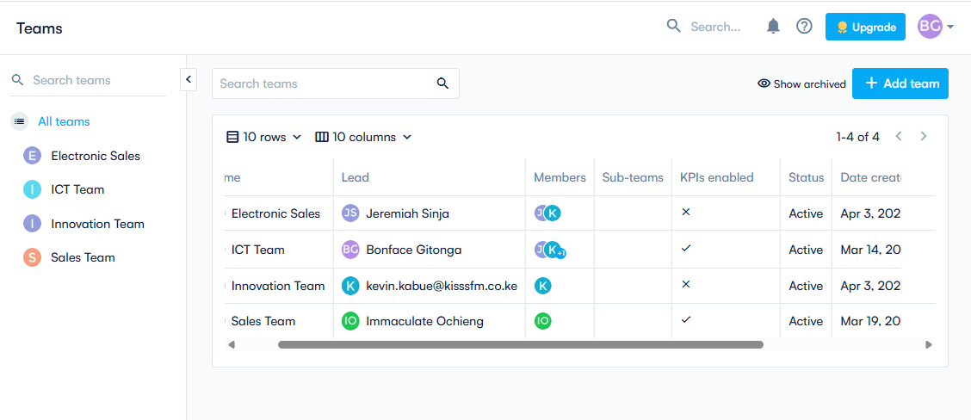

1. **Users Menu**

User management -Users Menuwhich will be used to create and manage users and also to create different access groups to assign permissions

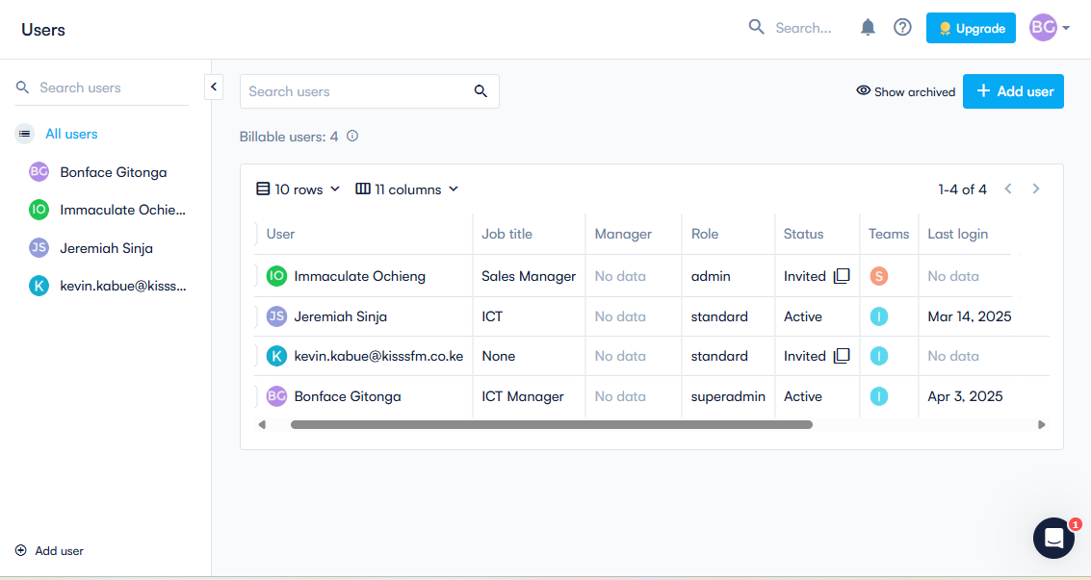

**Team Leads**

All Users

Admins

1. **Check-ins Menu –Create and View Check-ins**

-Show a list of team check-ins for managers by default

By Team Name:

By User:

-Show all check-ins for executive Team

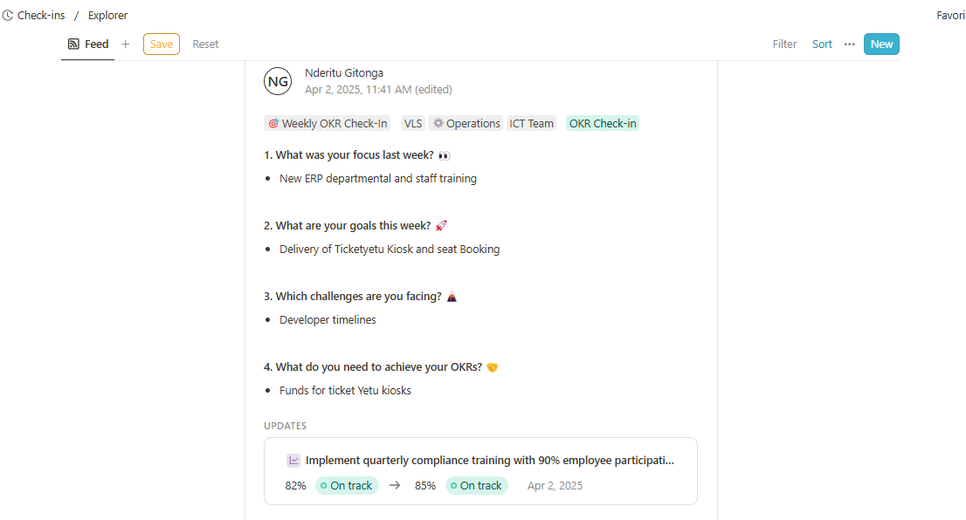

Add Filter

All Teams

My Teams

**-**Filter option should include

1. Add a view by My Team, should be default option for all managers
2. All Teams- Executive Team Only
3. Filter to View By specific Team and or by User
4. **Meetings Menu –Create and View Meetings**

By Team Name:

By User:

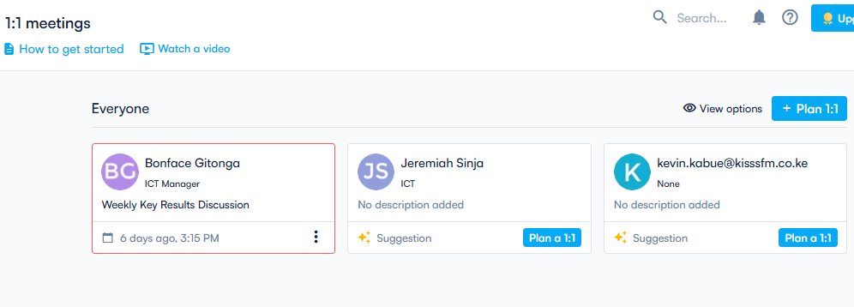

Add Filter

All Teams

My Teams

**-**Filter option should include

1. Add a view by My Team, should be default option for all managers to view current and scheduled meetings
2. All Teams- Executive Team Only should view all current and scheduled meetings
3. Filter to View By specific Team and or by User

**g) Resources Menu –On boarding progress Menu to show percentage covered and what is pending**

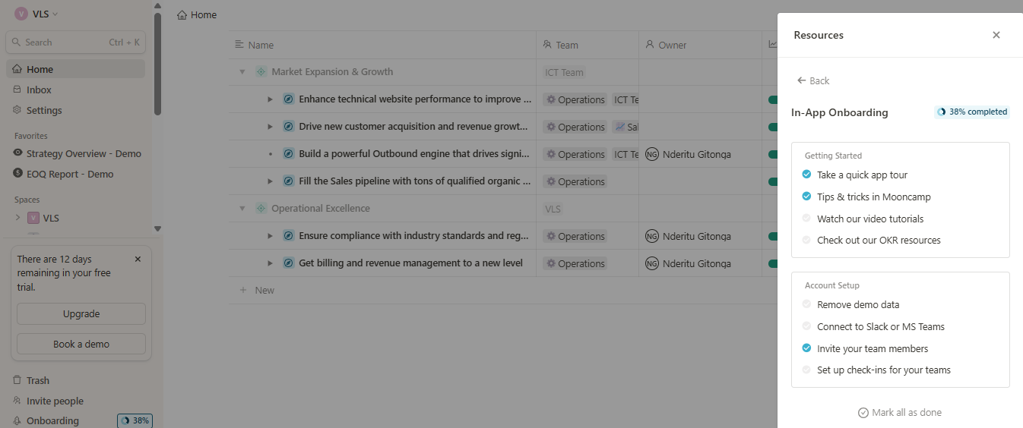

**h) Reporting Menu**

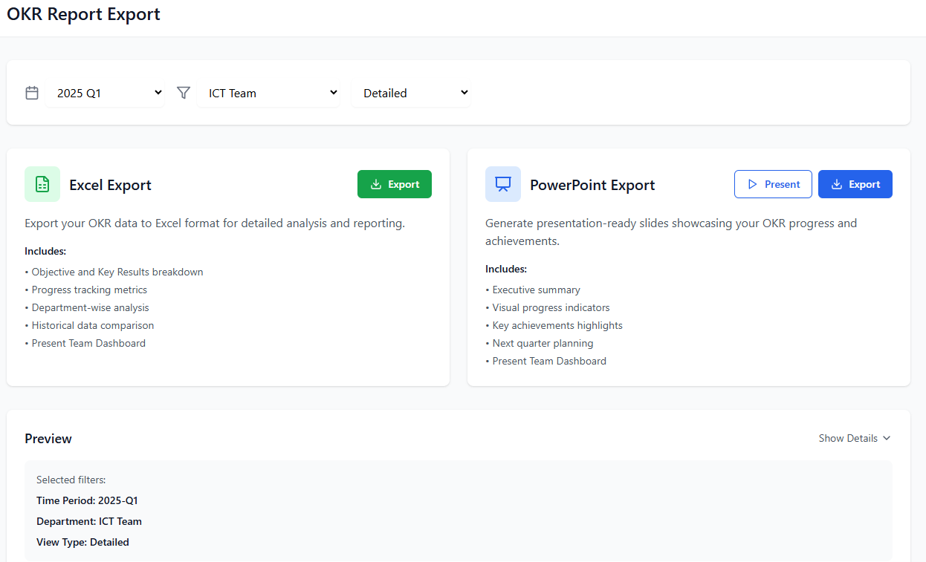

**i)Configuration Menu**



Enter the Company Address

Upload Company Logo

**3) Creating your Mission, boundaries and behaviours**

* Mission workspace will be used to entre a team’s/user’s Mission statement, Strategic direction, Vision, and values
  1. Mission Statement - A mission statement outlines the company's/teams purpose and long-term aspirations (entered by team leader)
  2. Strategic Direction –Align teams Mission with higher strategic (Pulled from CEO Company Mission)
  3. Vision –Company Vision – (Automatically pulled form CEO/Company Strategy)
  4. Values –Company values ––(Pulled form CEO dashboard/Company Strategy)
  5. Boundaries –Which will contain Freedoms and Constraints for specific departments (entered by team leader)
  6. Behaviors- How team leaders intend to adopt new behaviors to drive and accomplish their OKRs(entered by team Leader)



-Adding your mission and strategic direction,-Once a user clicks edit provide below screens for editing

* Editing the Mission

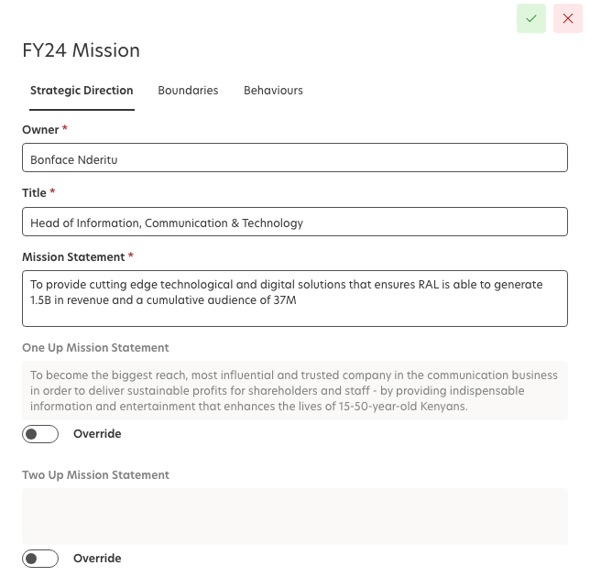

Save

* Creating Boundaries

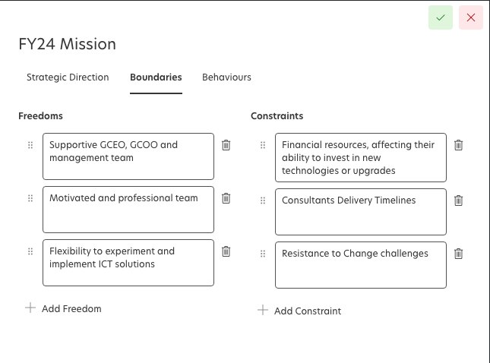

Save

* Creating Behaviour’s

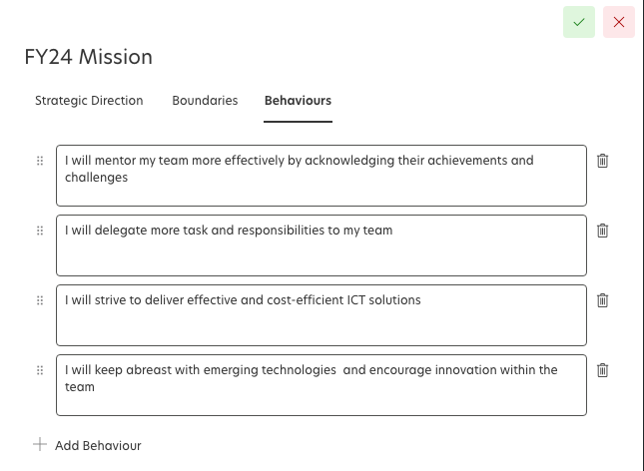

Save

**4. Core OKR Management –Creating Objectives and key results**

-Under Create OKR button we should have 3 options as shown below

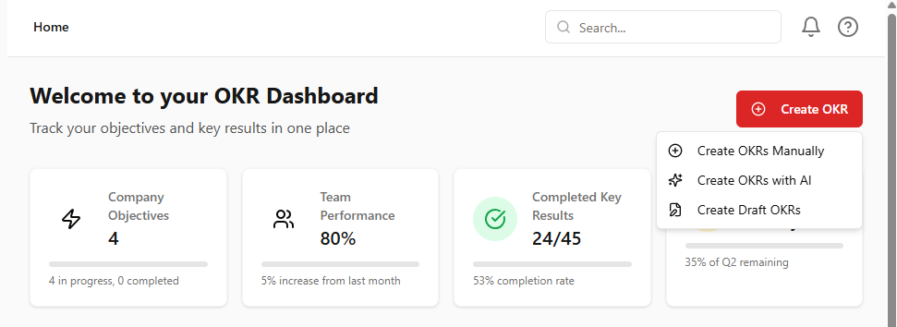

Options should include:

* Create OKR’s with AI -(will use AI)
* Create OKR-Create OKR Manually
* Create Draft OKRs

**Create OKR - AI option**

a) Create OKR’s with AI option will redirect you to a new page a shown below with 2 options Users and achievement

* Users/Team option- that will be involved with specific OKR
* Achievement -What do they intend to archive

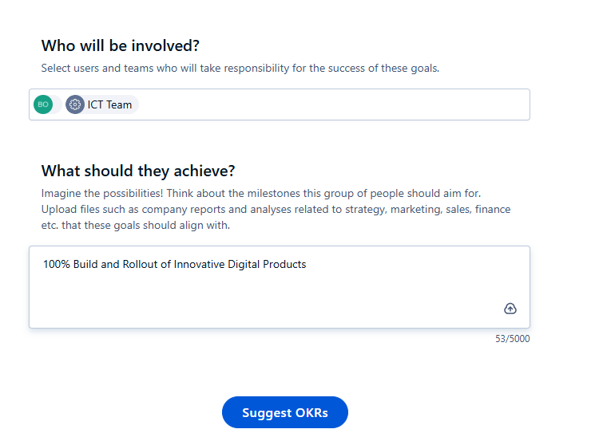

Create OKRS

b) Create OKRs button triggers AI to create 5 objectives based on the team and achievement entered as shown below

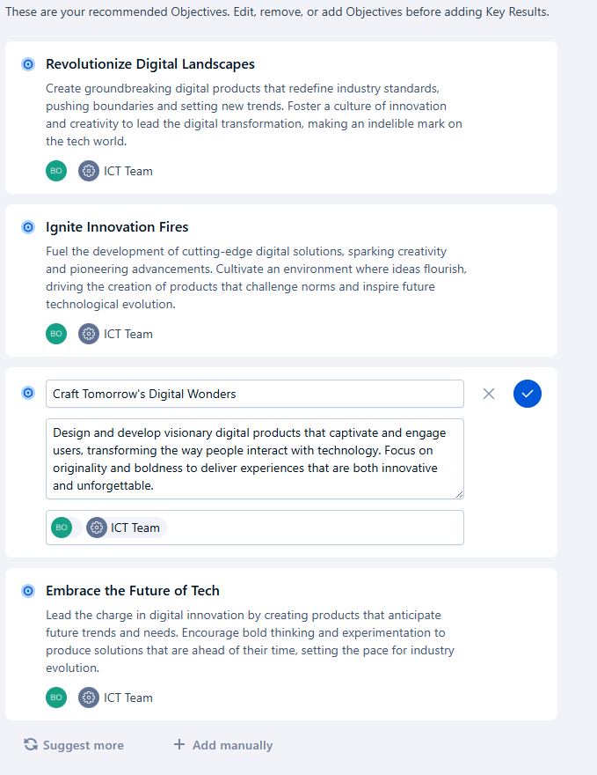

-Under Suggested OKRs, a user has several options which include

* Ask AI to suggest more OKRs
* Add other OKRs manually
* Edit specific suggested OKRs as shown on the 3rd suggestion

c) After creating and editing your objectives- Next step is to **Suggest/Create Key results** using create key results button as shown

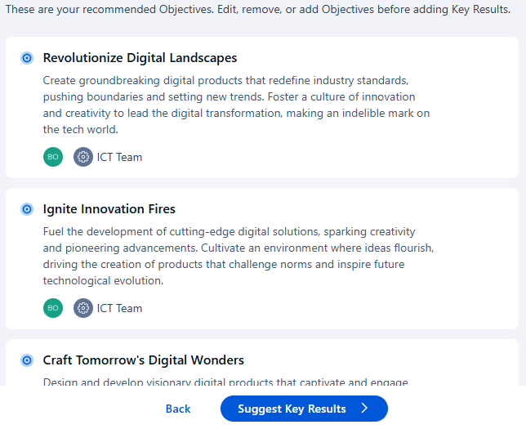

Create Key Results

d) Create **Key results** page view

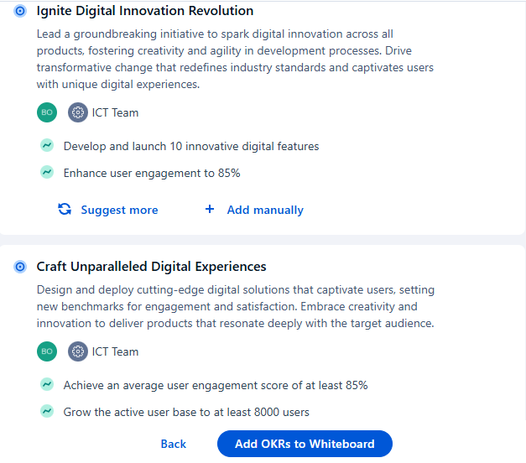

Save OKRs to Draft

Key results are generated as shown on above screenshot, it also provides 3 options

* Ask AI to suggest more Key results
* Add other Key results manually
* Edit specific suggested key results as shown below

e) Save OKRs to Draft

Save OKRs to draft option allows you to save a draft copy of the OKRs before publishing to live as shown below

Review OKRs with AI

Publish OKRS

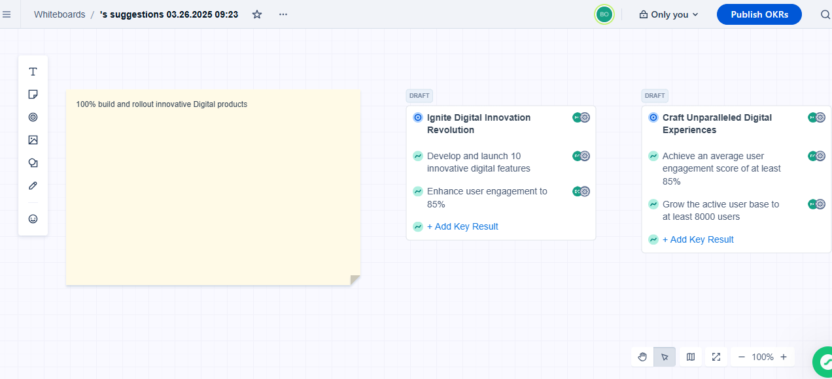

f) Under the Draft OKR option add a button to enable users to review OKRs with AI as shown on above screenshot, this option will enable users view feedback on their OKRs based on OKR principles and provide edit suggestions or improvements

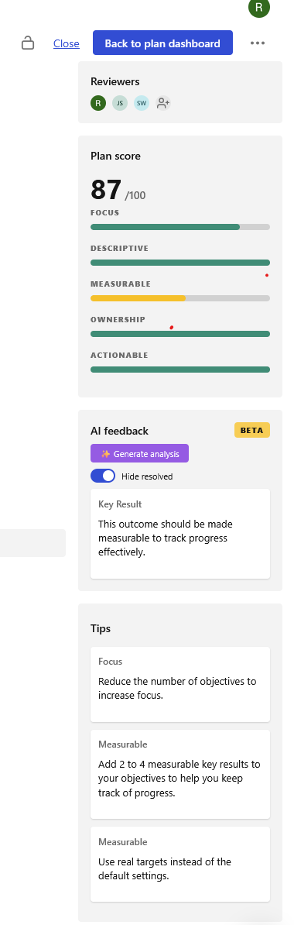

Review OKRs with AI

g) Once OKRs are published show the Team/User dashboard as shown below

My OKRs

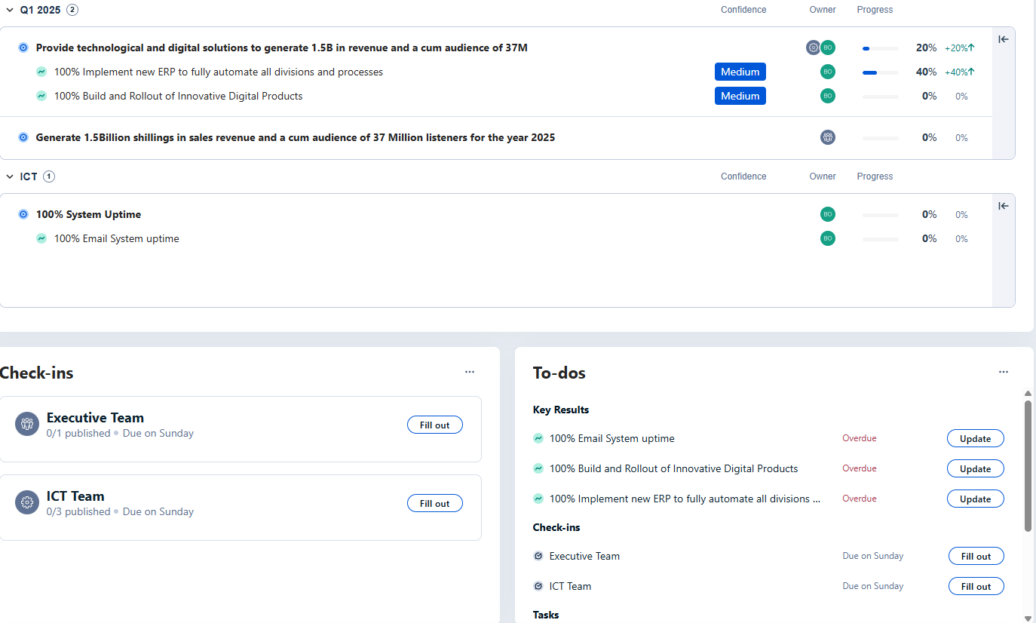

-Display dashboards for each team/users, showcasing their objectives, key results, check-ins, to-dos, and tasks all in one view for easy management and navigation.

**Create OKRs- Manual option**

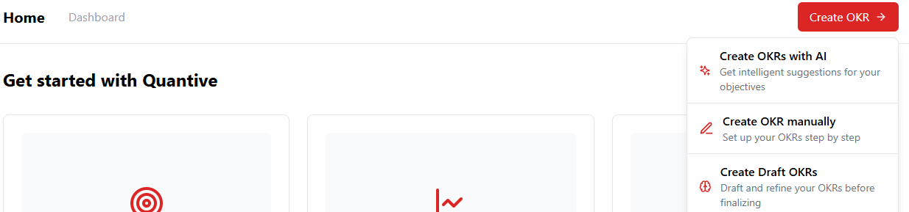

1. **Creating Objectives**

* User’s select to create OKRs Manually option open the Add OKR page and provide the below options

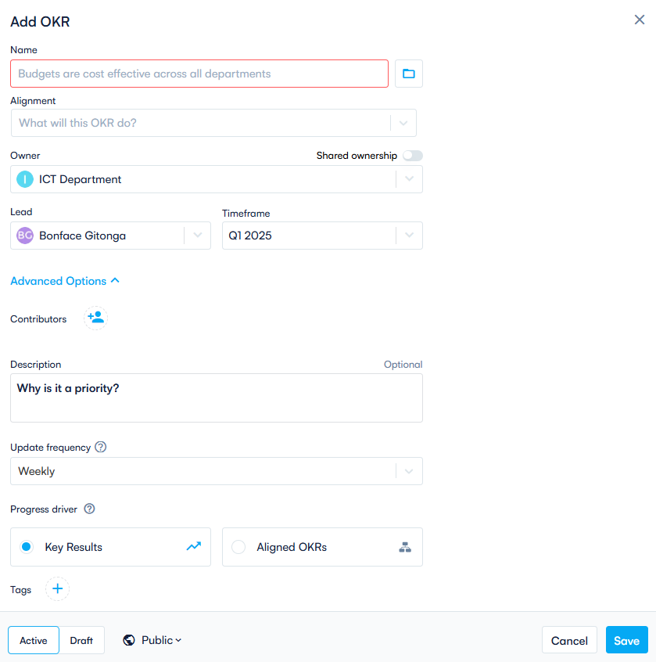

* **Add OKR** -Enter Objective Title (Be inspirational and provide Clear Objective, it should also not contain a metric)
* **Alignment** -Align it with a Goal or Higher-Level Objective (Pick which goal this Objective supports)

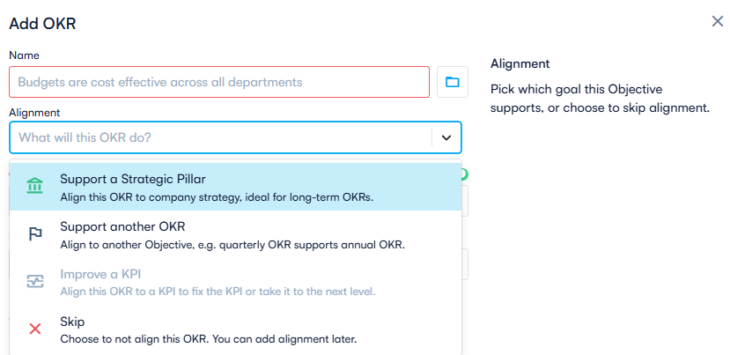

* Creating alignment between company strategy and Objective

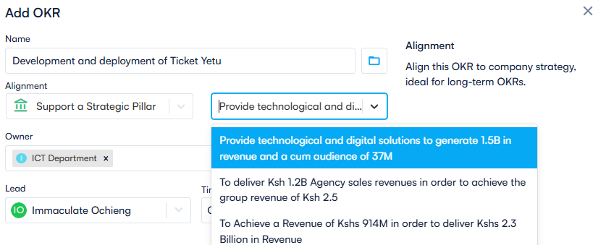

* **Owner**-Assign Ownership (which Team is responsible for this objective)

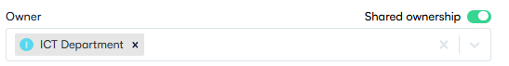

* **Shared Ownership toggle button**- Allows you to select more than 1 team if an objective is shared between departments

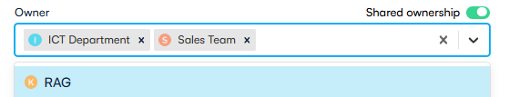

* **Contributors** -Add contributors option (People responsible for creating/completing initiatives that supports the OKRs progress

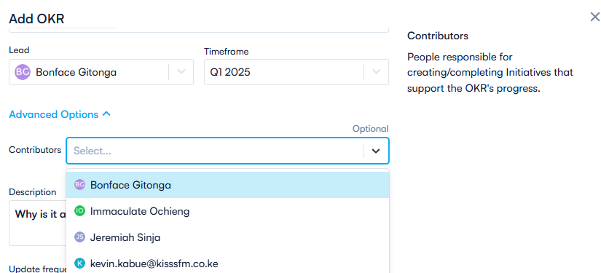

* **Lead** –Assign the Lead (The Person that is ultimately accountable for this objective)

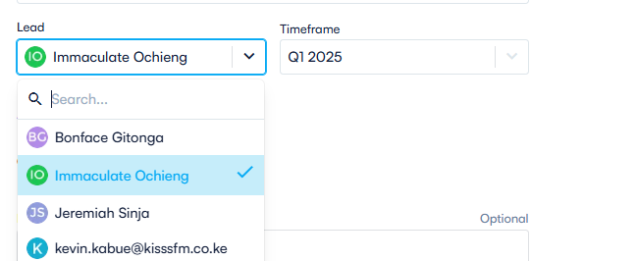

* **Description/Priority** –Reason why it is a priority

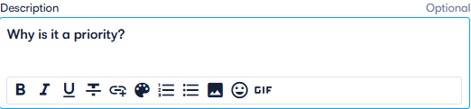

* **Timeframe-** Q1, Q2, 2025 (Time period in which the Objective needs to be archived)

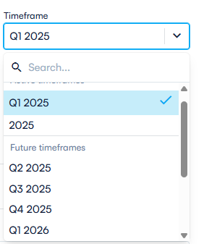

* Update frequency

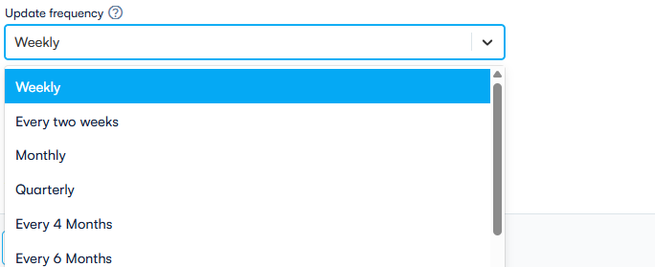

* **Tags** –Add Tags to easily find related Objectives via filters and search fields

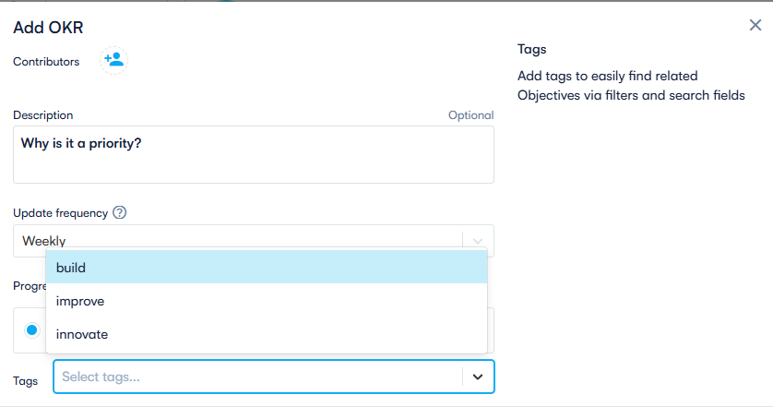

* **Progress Drivers** –Key results will be used to measure progress for the objectives

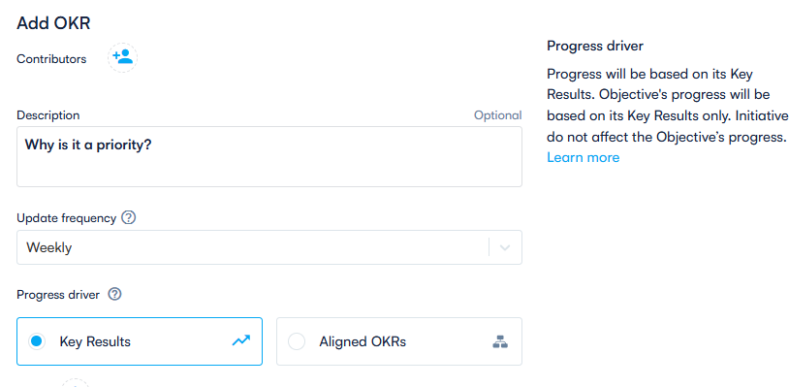

* Permission/Rights options – Who is permissioned/allowed to view the objective

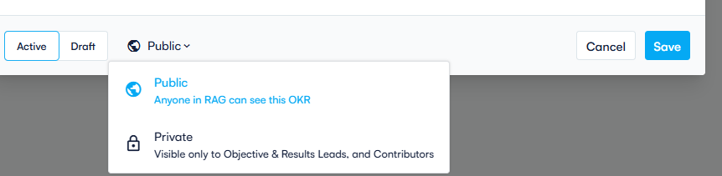

* Final Objective Sample with data

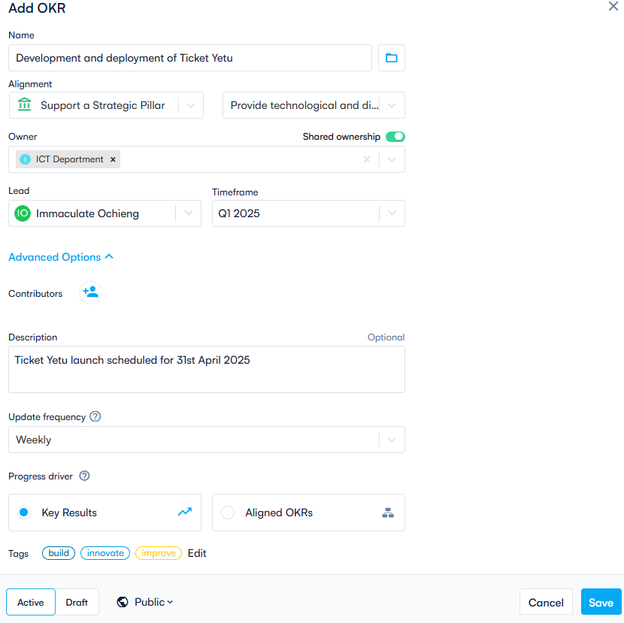

**b) Creating Key results on objectives**

After clicking **"Save,"** on the Objective creation page the system should **automatically redirect to the Key Results/Initiatives setup page**

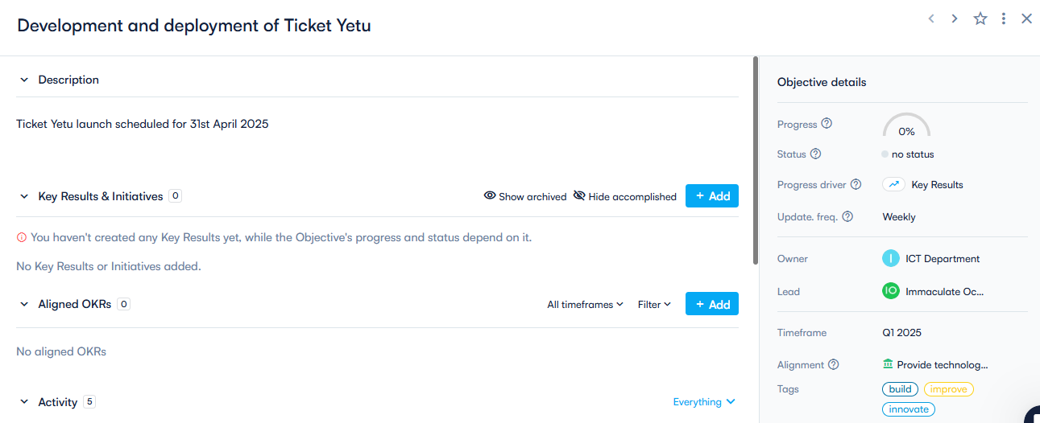

* Click **Add button** under Key results and initiatives to add a key result

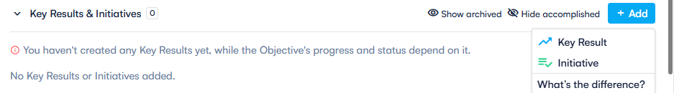

* Opens the **add key result or initiative** page as shown below

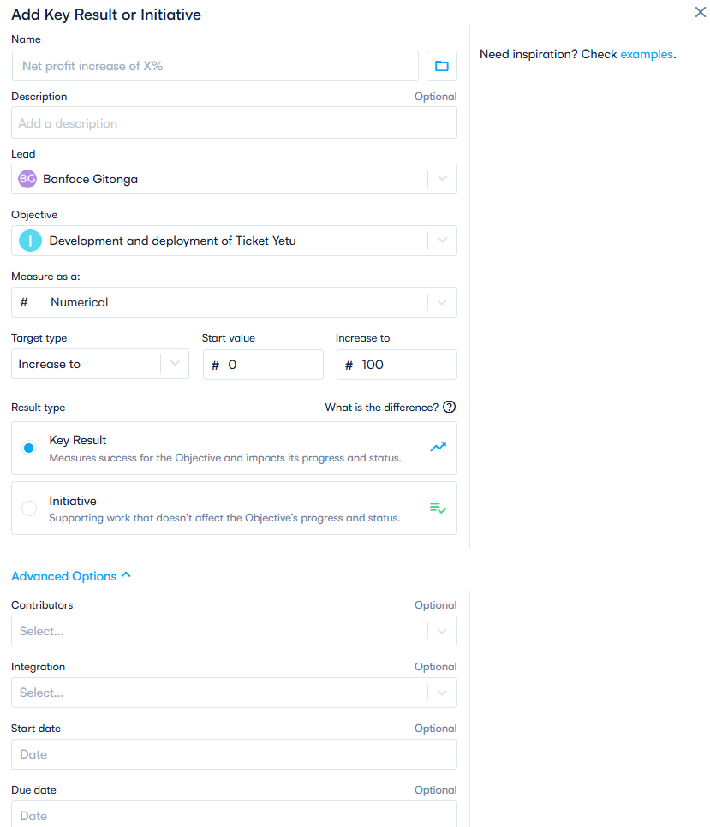

**Key Results options Explained**

* **Name** -Enter title of key result and its measure, Provide suggestions by category as shown below, we can also ask AI to suggest based on category as shown below

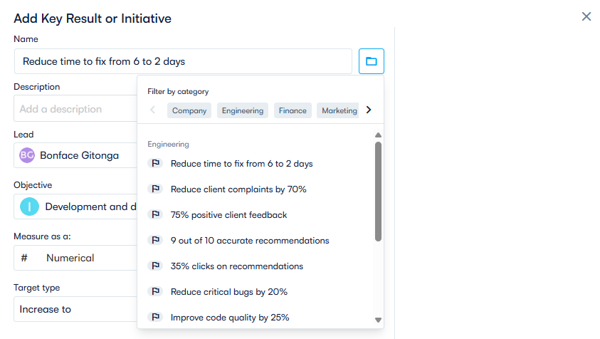

* **Description**-Add a description of the key result

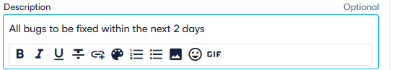

* **Lead**-Assign Lead –The person responsible for the Key result

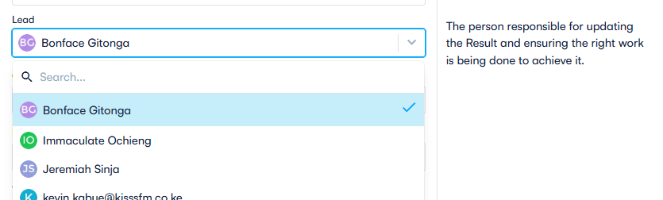

* **Objective**-Shows the Objective to which the key result is aligned to

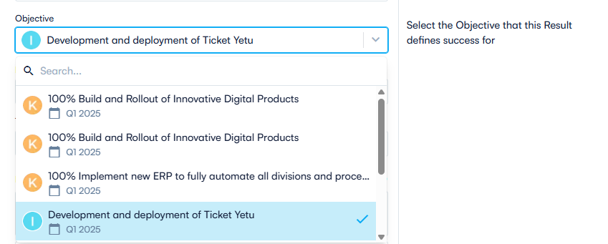

* Measure –What’s the unit of measure e.g. Percentage, KSH, Numeric

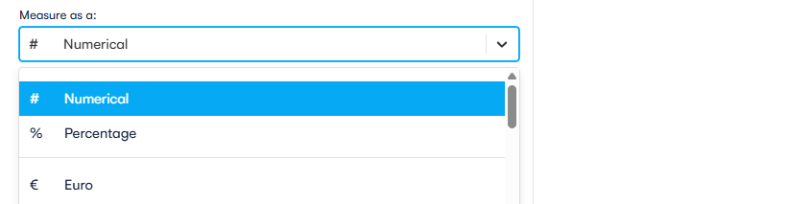

* **Target type**- Start and end value

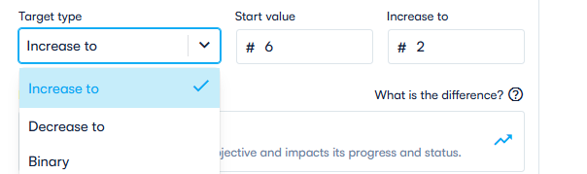

* **Result type** –Key result or initiative

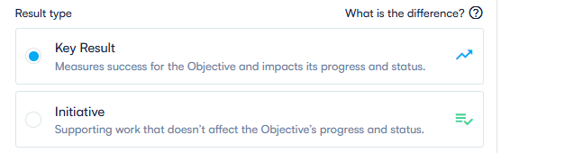

**Key results** - Key Results are a set of metrics that measure your progress towards the Objective and are directly under your control

**Initiative** - What will I do to get there?" Initiatives are the concrete tasks, actions or projects that you do to help achieve your OKR.

* **Contributors** –Individuals responsible for helping the Lead complete a Key result should show members of a given team

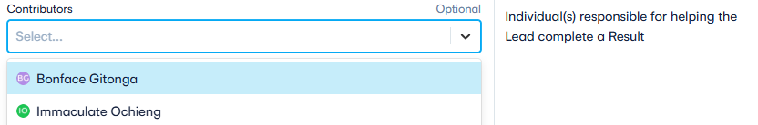

* **Integrations** –redirects you to the connected APIs and integrations page which allows you to select a data source e.g. google sheets or slack

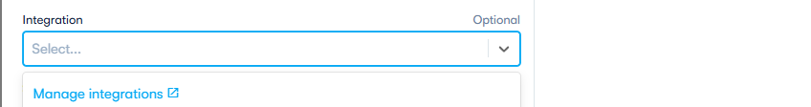

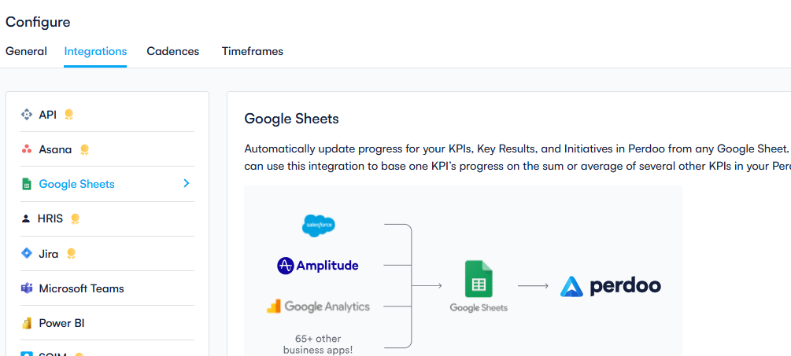

* **Start and Due date**-Add a Start and end Date

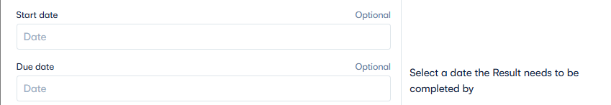

* Calendar view as shown below

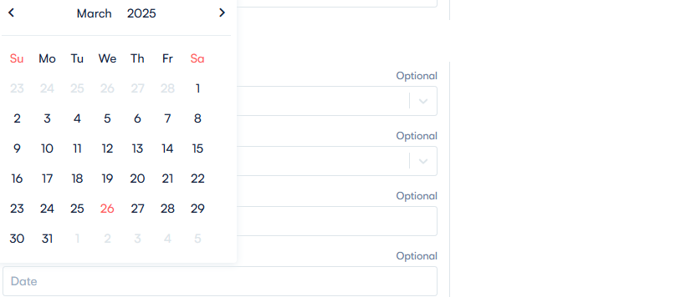

* Tags –Add Tags to simplify filter and search options



**Key results with Sample data**

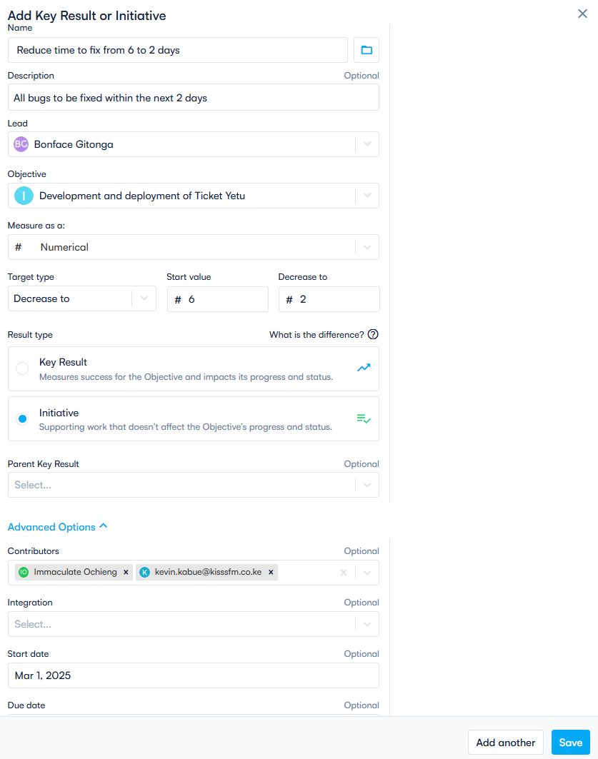

**c) Creating Initiatives**

* Click Add button under Key results and initiatives to and select initiative

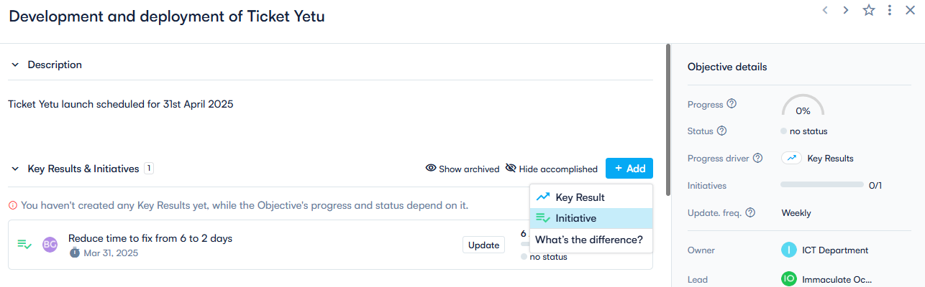

-Select Add –Create initiate option as shown above

* Create initiative page –Similar to create Key results page as explained above but has a key result parent key result option

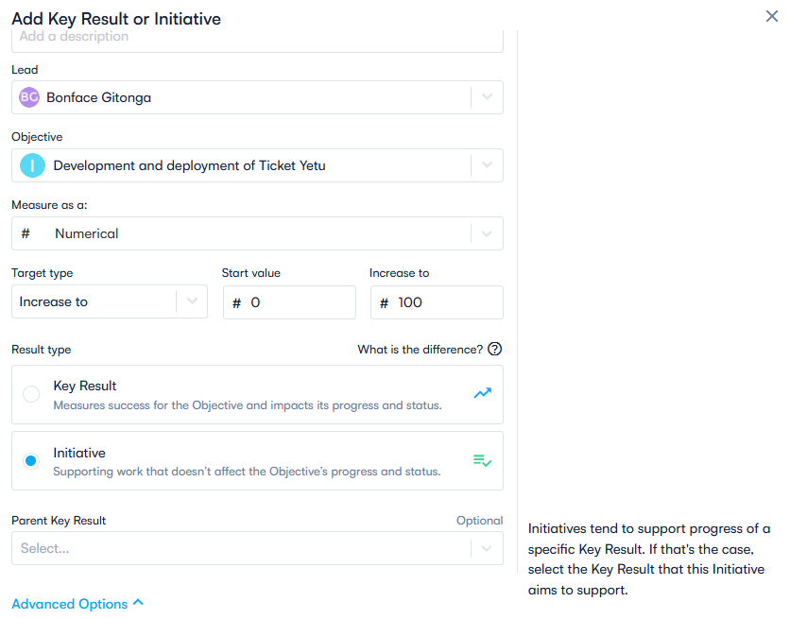

-Created Initiatives and key results sample view

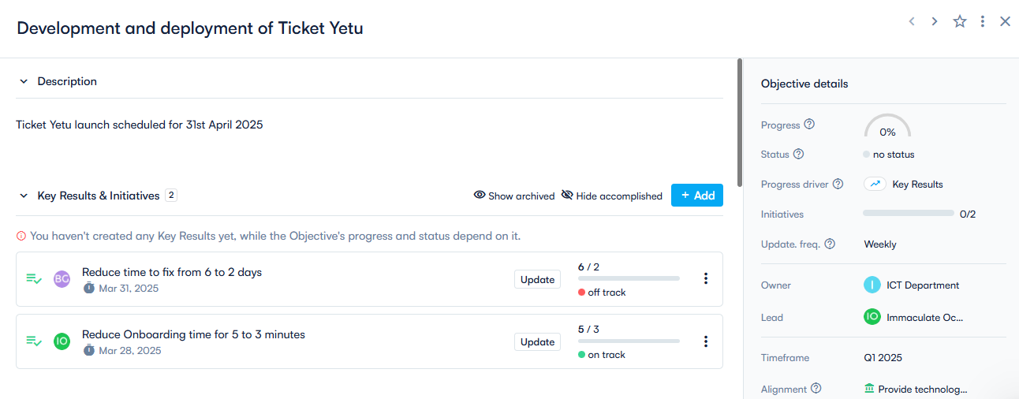

**d) Updating Objectives and Key Results**

a) Should include all the objective details as shown below

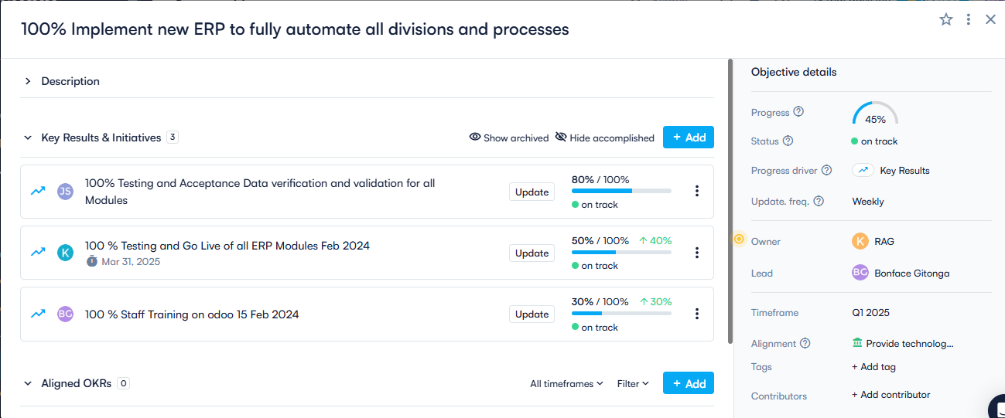

Options

* **Progress** - Is based on the Objective's Key Results, which are all weighted equally. Initiatives and Aligned OKRs don't affect its progress..
* **Status-** is based on the Objective's Key Results. Initiatives and Aligned OKRs don't affect the status.
* Progress and status is based on the Objective's Key Results, which are all weighted equally.
* **Update frequency** -Select a custom update frequency for this goal. Note: your default update frequency is based on timeframe set under configurations menu.
* **Alignment** -Pick whether this Objective supports a Strategic Pillar, another Objective or supports a KPI

**e) Updating Key results and status**

* Key result progress and tracking should be at task-level and independent of each other.
* Users should only be able to update key result assigned to them.

-To update the progress on a key result click on the **update button**

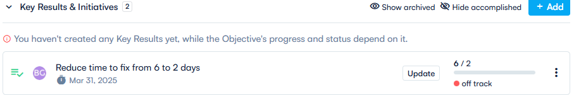

-Enter the **New value** and select the **current status** as shown below, you can also add comments in regard to the update

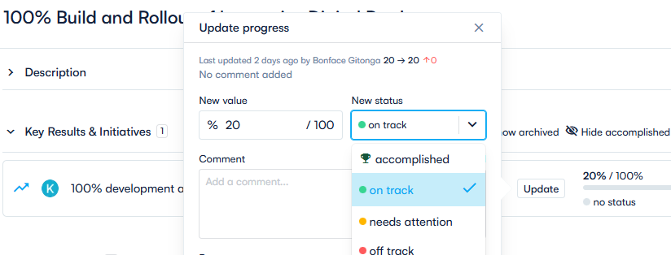

* Updated key results view sample

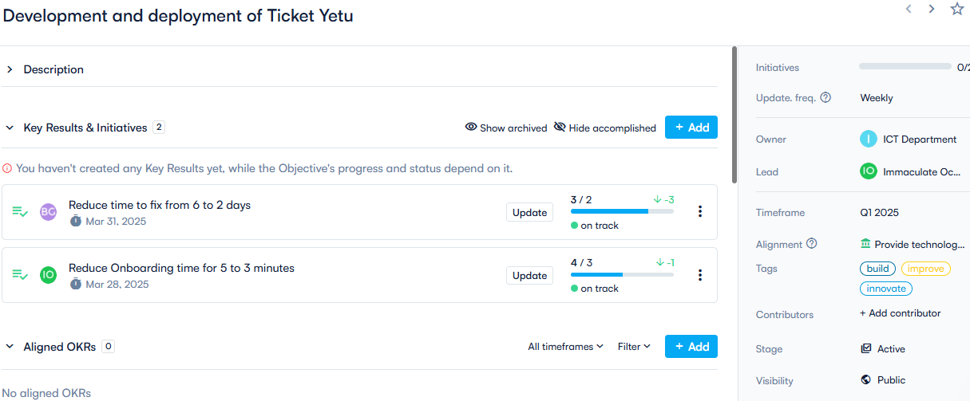

**4. Progress Tracking and Percentages view**

-Display personalized dashboards for each team leader under dashboard menu, showcasing their objectives, key results, check-ins, to-dos, and tasks all in one view for easy management and navigation.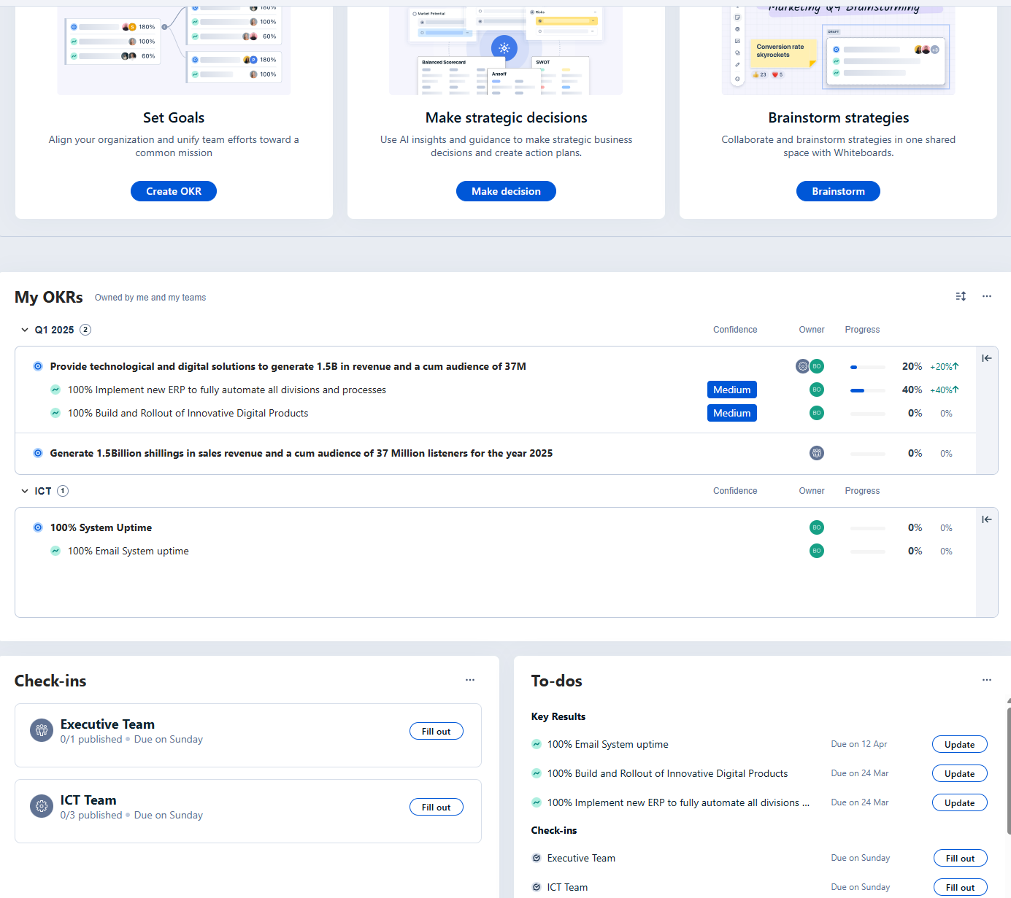

**-**Display Objectives, Key results progress using colour indicators and percentages under the user’s home profile

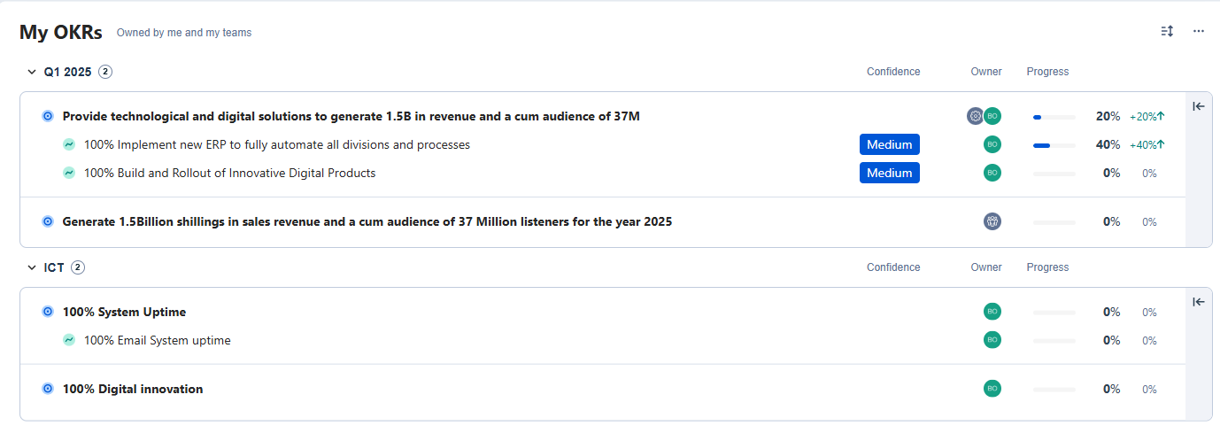

-Once a user click on an objective form the dashboard, redirect them to the objective page

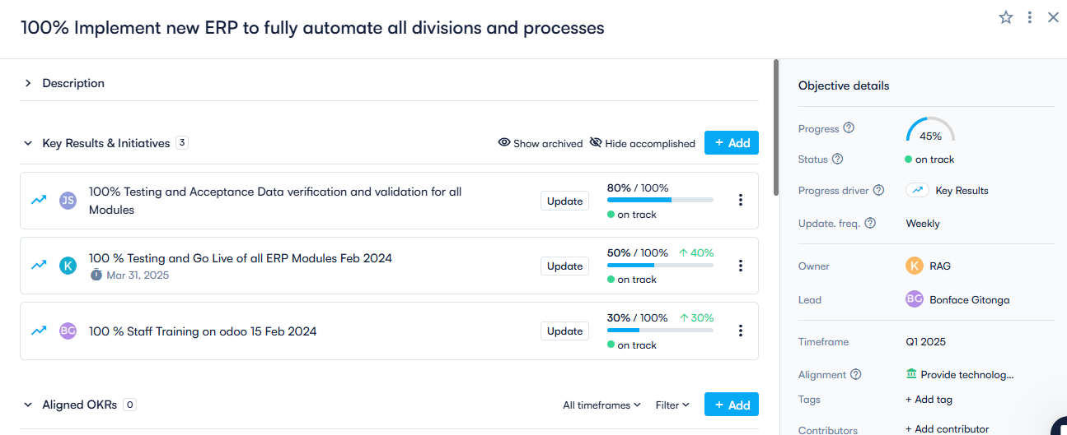

-From here users should be able to update their progress and the specific objective details, initiates and key results

**5. Cadences and Timelines**

**About cadences and timeframes**

**What are cadences and timeframes?** Cadence is nothing more than the frequency with which you create goals.

A cadence refers to the frequency with which you set and review goals, e.g. Annual, Quarterly or Monthly.

A cadence is simply a series of recurring timeframes. I.e. Annual, Quarterly, Monthly

**What is a timeframe?**  A timeframe is a single date range. I.e. Q1 2019 (Jan 1, 2024 - Mar 31, 2024); 2025 (Jan 1, 2025 - Dec 31, 2025)

**Which cadence works best?**

OKRs typically work with a combination of cadences that interact with each other to create a rhythm of continuous and focused progress. You have a high-level goal with a longer horizon that can only be accomplished by working toward smaller goals with a shorter horizon.

The standard combination in the OKR framework is **annual and quarterly**.

* **Annual OKRs** communicate the core themes that the company (and sometimes departments) wants to achieve by the end of the year.
* **Quarterly OKRs** are the short-term goals that teams will generate to help achieve the company's annual priorities.

NB: Under Configuration Menu on the home page add Cadences and Timeframes which will be used to create and manage them

**-Creating cadences**



-**Add Cadence**



**-Adding timeframes**

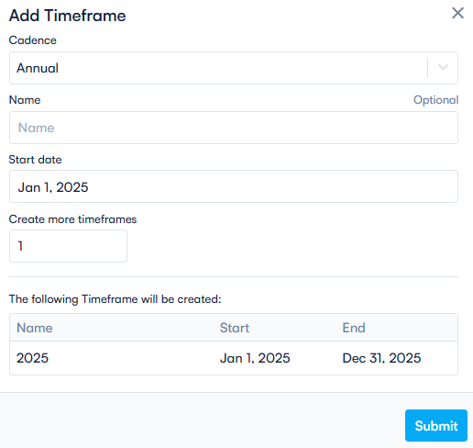

**6. Collaboration and Engagement (Check-ins and 1:1 meetings)**

**a) Check-ins**

**Weekly and Daily Check-ins** feature helps teams stay aligned, accountable, and engaged by encouraging regular updates on key results and objectives. These check-ins ensure that progress is tracked consistently, challenges are identified early, and teams remain focused on their priorities.

#### Key Features:

### 1. Daily Check-ins *(Quick Progress Updates & Prioritization)*

* **Short, structured updates**: Employees can quickly log what they worked on, what’s next, and any blockers.
* **Real-time visibility**: Managers and team members stay informed about daily progress without unnecessary meetings.
* **Integration with collaboration tools**: Sync with Slack, Microsoft Teams, or email for seamless reporting.

### 2. Weekly Check-ins (Deeper Reflection & Alignment)

* **Comprehensive status updates**: Employees provide a summary of their weekly progress on OKRs.
* **Highlight achievements & challenges**: Teams can flag roadblocks early and seek support.
* **Automated reminders & templates**: Encourages consistency and ensures meaningful check-ins.
* **Manager feedback & comments**: Enables continuous support, coaching, and course correction.

### 3. Engagement & Accountability

* **Encourages team-wide participation**: Everyone stays involved in tracking progress and adjusting priorities.
* **Increases goal transparency**: Helps align individual contributions with team and company objectives.
* **Fosters a culture of continuous improvement**: Encourages proactive problem-solving and course correction.

-Provide a feature for weekly and daily check-ins add the menus on left side bar of the home screen

* 1. Creating Check-ins templates

Provide a feature to create different check-in templates as demonstrated below

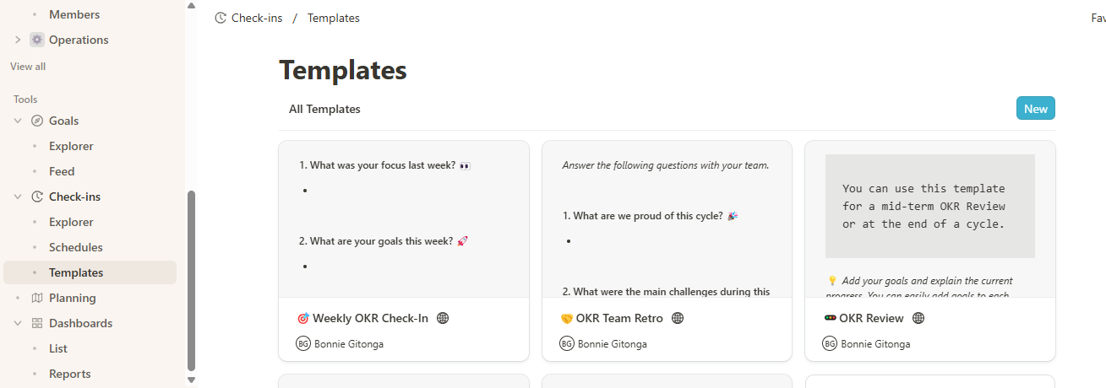

-Above feature will be used to define different check in templates

-To create a new template, click New and enter below fields

* **Name:** Name of the check-in template
* **Team:** Select the team to be assigned the check-in template
* **Check-in Type**: Select the check-in type i.e OKR Check-in, OKR Retrospective, and OKR Review

Note below sample

-Check-in template sample

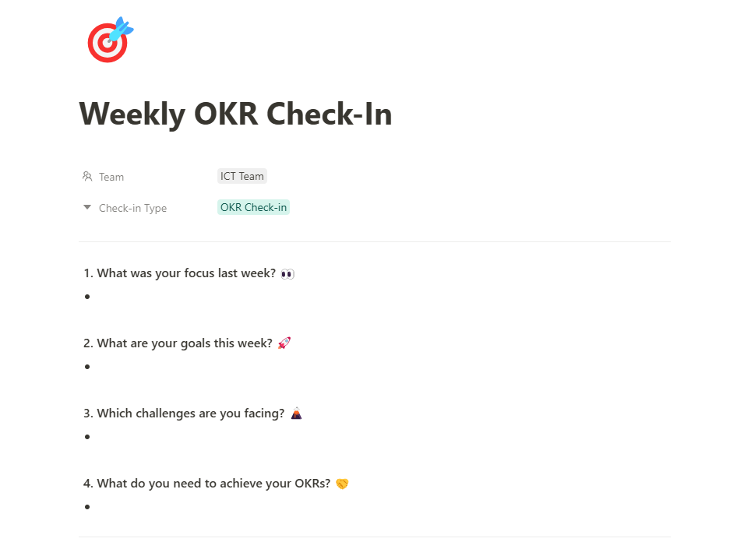

-Creating Weekly Schedules

Feature will assist user create and schedule different check-ins as shown below

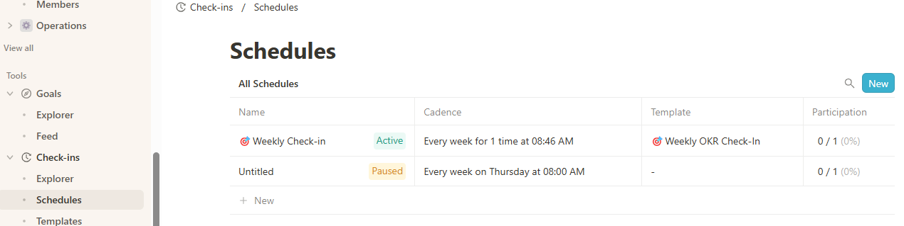

-To create a check-in schedule user will click New

**Name**-Add a Name for the Schedule

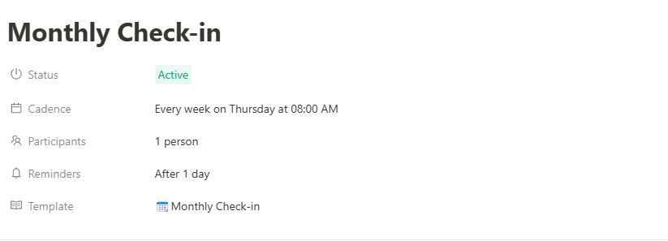

**-Status**: Paused or Active

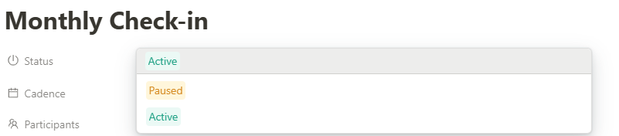

**Cadence:** Set Recurrence Day and Time

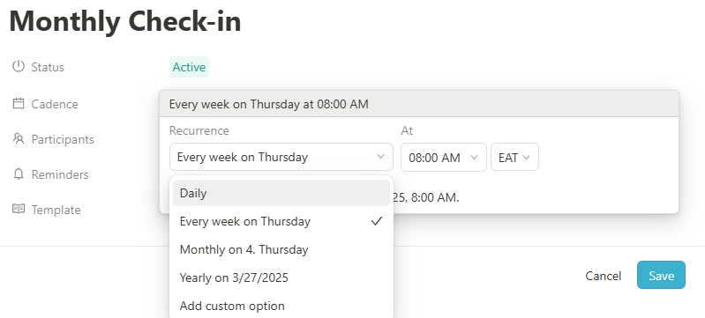

**Participants** –Persons/Team that need to do the check-ins

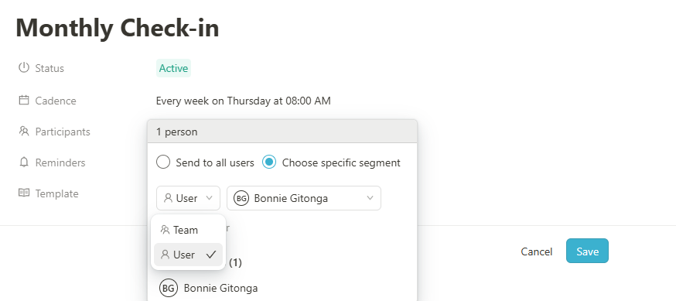

**Reminders** –Schedule reminders

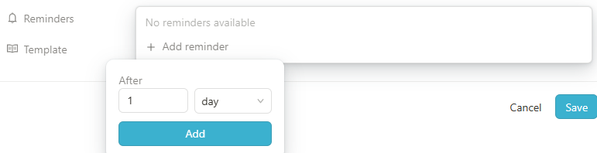

**Template**-Allows you to select from the Active Predefined Templates

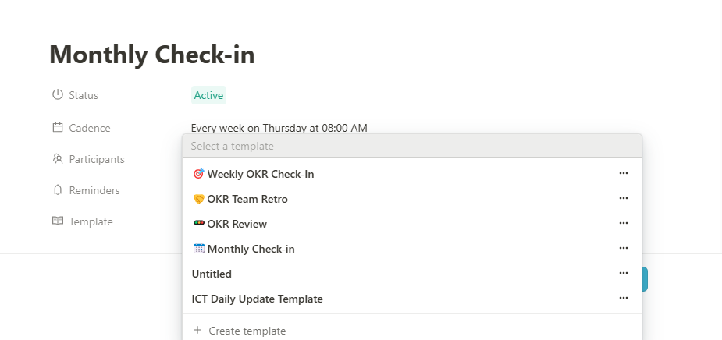

**Check-In Metrics**- Under all active and running check-in ensure to show analytics on responses as shown below

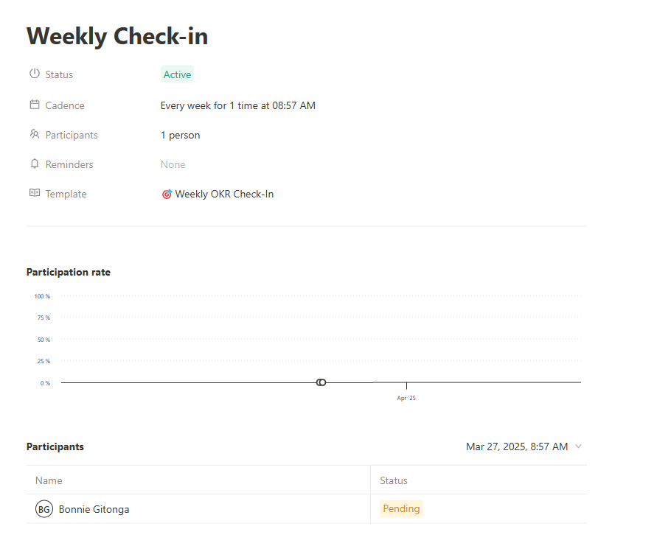

**Update key results with weekly check-ins**

**-**Feature will enable user to update their objectives and key results while doing there weekly check-ins

Add a New Objective/Goals update button

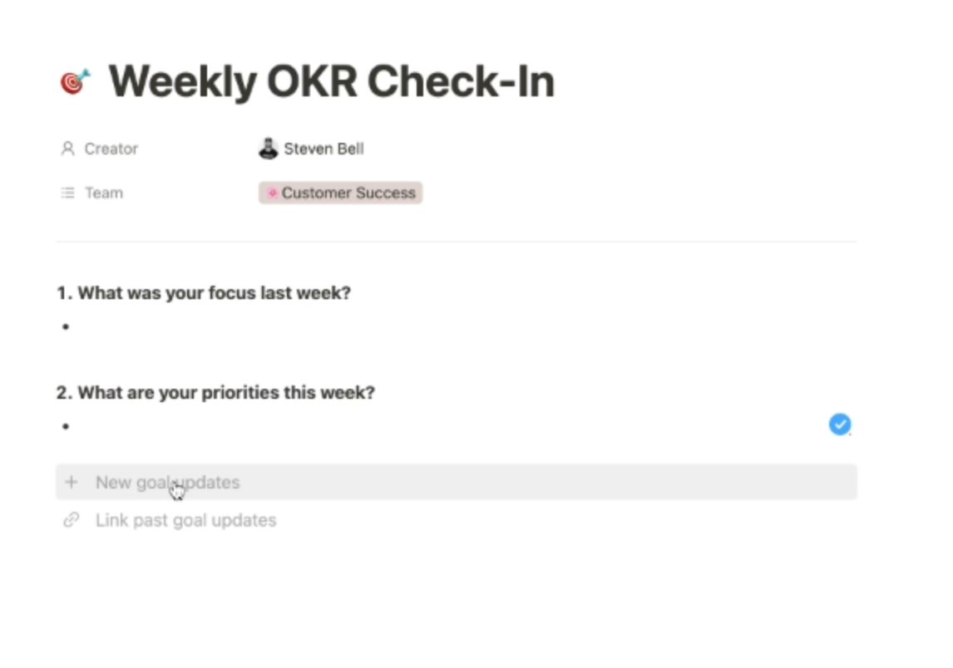

-The add button will navigate the users to select the teams Objectives and key results they want to update as shown below

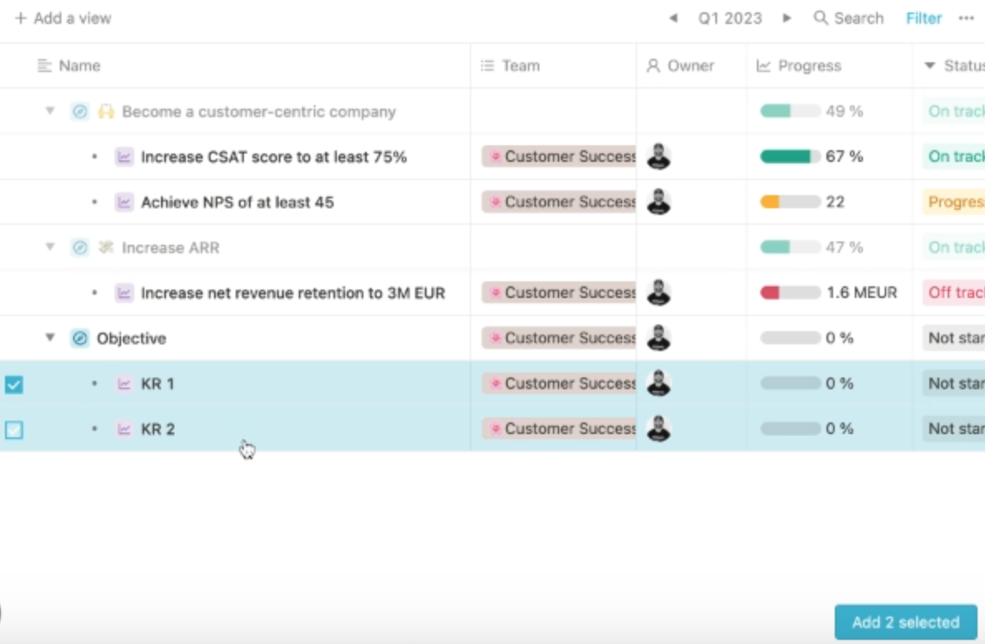

-Update and submit updates to selected objectives and key results as shown below

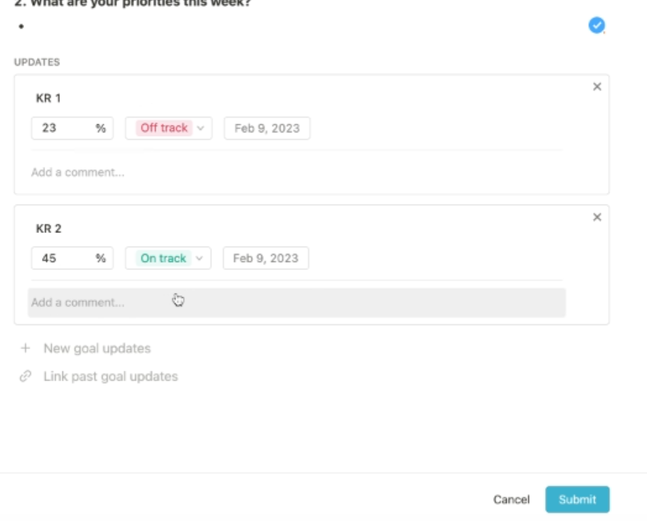

**b) 1:1 Meetings**

**1:1 Meetings** feature is designed to facilitate productive conversations between managers and employees, ensuring alignment, feedback, and continuous development. By integrating with OKRs, these meetings help connect individual performance to broader company goals while fostering engagement and accountability.

**Key Features & Benefits**

**1. Goal-Oriented Conversations**

* Directly link 1:1 discussions to individual, team, or company OKRs to maintain focus on strategic priorities.
* Track how personal objectives contribute to broader organizational success.
* Ensure transparency and alignment in performance expectations.

**2. Collaborative Agenda Setting**

* Both managers and employees can **add discussion topics** in advance to structure conversations.
* Use **pre-built agenda templates** tailored for performance reviews, development talks, and check-ins.
* Prioritize key talking points to make meetings more effective.

**3. Progress Tracking & Follow-Ups**

* Document **meeting notes** and **key takeaways** to maintain continuity over time.
* Assign **action items** with due dates and track completion.
* View past meeting summaries to ensure consistency and accountability.

**4. Continuous Feedback & Coaching**

* Enable **real-time feedback** within the platform to recognize achievements and address challenges.
* Support employee **growth and career development** through structured coaching conversations.
* Keep performance discussions ongoing rather than limiting them to annual reviews.

**5. Seamless Scheduling & Integration**

* Sync meetings with **Google Calendar** or **Outlook** to streamline scheduling.
* Receive automated reminders to ensure regular check-ins.
* Integrate with **Slack or Microsoft Teams** for meeting updates and notifications.

**6. Engagement & Performance Insights**

* Monitor **meeting frequency and quality** to gauge employee engagement levels.
* Identify trends in **performance, morale, and challenges** based on recurring topics.
* Use data-driven insights to enhance leadership effectiveness.

1. **1:1 Meetings –Creating a 1:1 meeting**

-Add a Menu on the home screen for 1:1 meetings

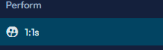

-Creating a 1:1 meeting

Under 1:1 meetings click on plan

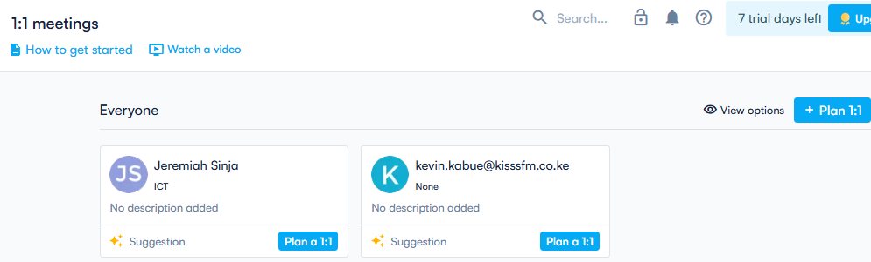

-1:1 planning page

**Meeting with**: User to meet

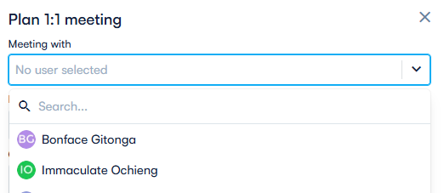

**Description**-Brief description of the 1:1 meeting

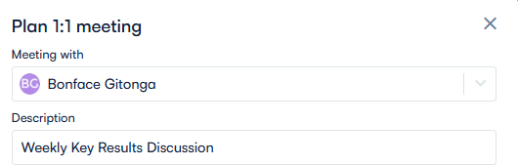

**Calendar** –Google calendar

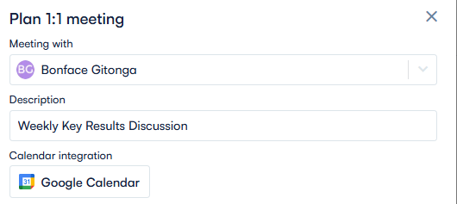

**Frequency** of the 1:1 Meetings

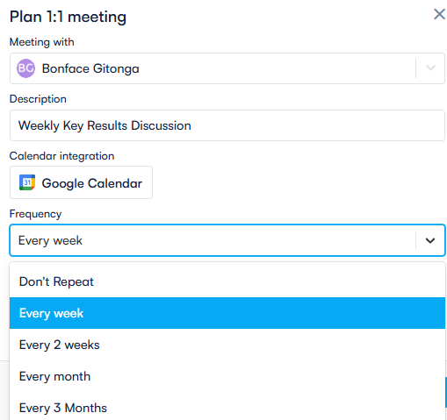

**Meeting Date and Time**

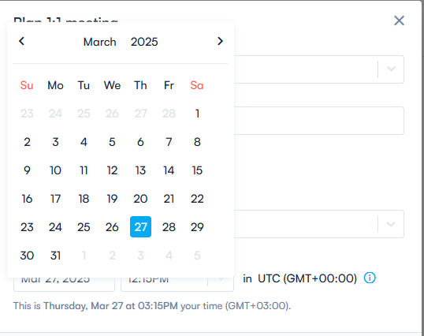

-Once saved a **notification email** will be sent to the recipient’s inbox as shown below

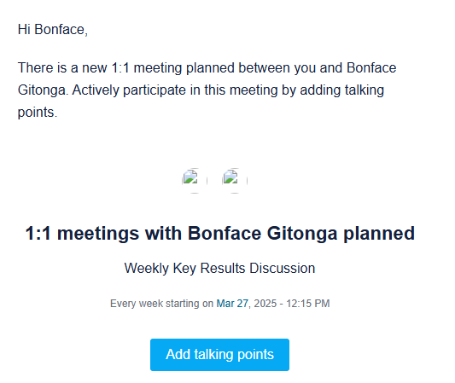

-Adding **talking Points**

Once a user selects add talking points redirect them to the 1.1 meeting and provide below options

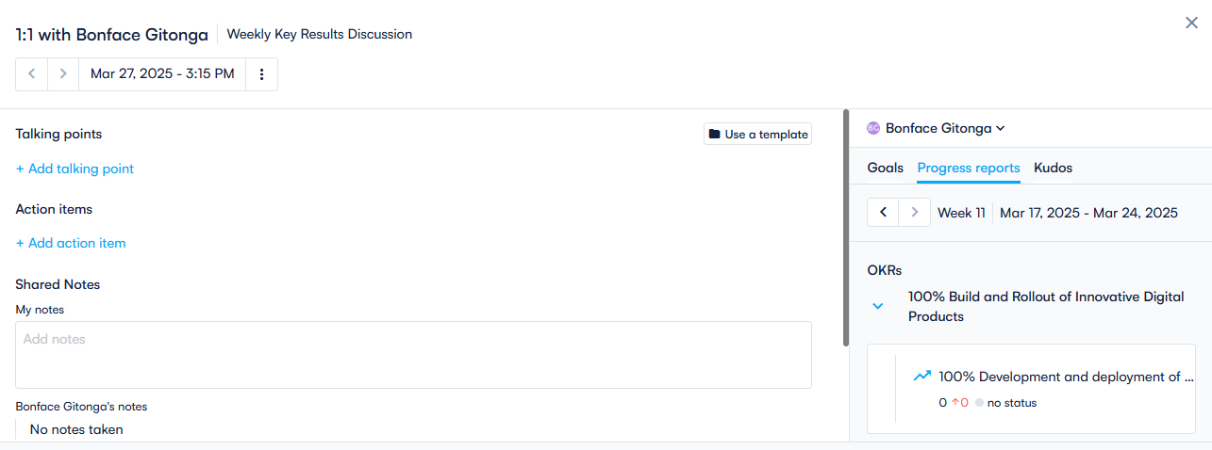

* 1. Talking points -add points you wish to discuss in the meeting
  2. Add Action item –Add Action Points
  3. Shared notes- Meeting notes
  4. Private Notes- Add your own notes

-On the Left panel of the talking Points page

**Progress reports:** Show all the users Objectives and Key results and there status

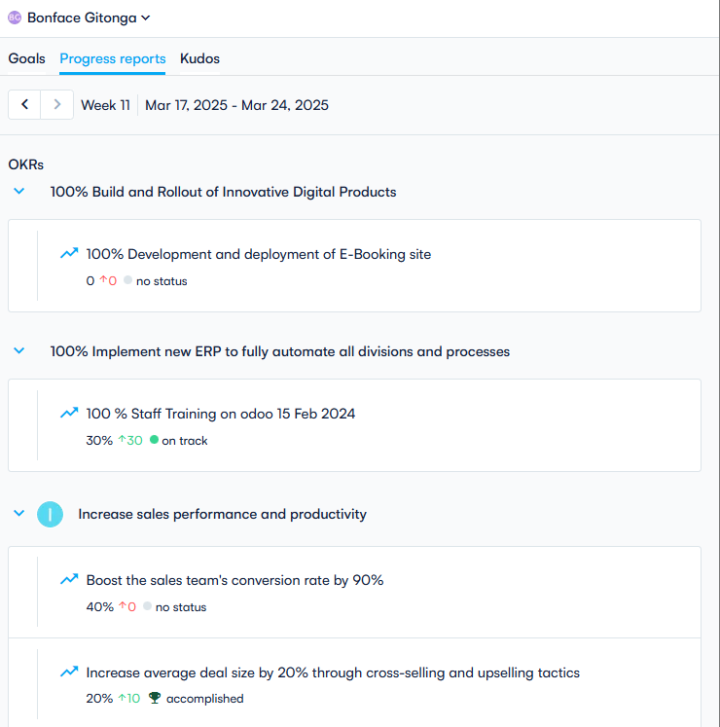

**-Goals/Objectives view Menu**

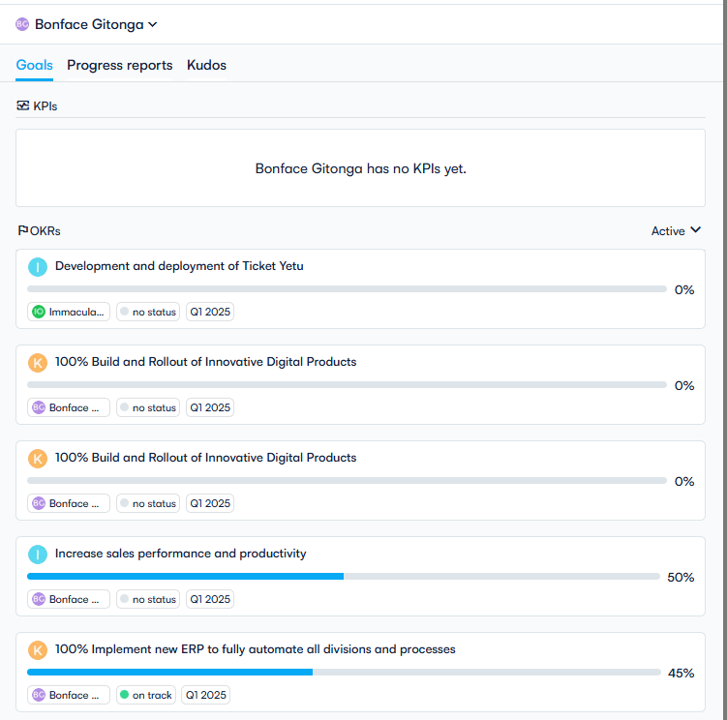

**7. Feedback loop and recognition**

**Kudos** feature is designed to enhance employee engagement by enabling teams to recognize and celebrate achievements in a meaningful way. By integrating user recognition with OKRs, Kudos ensures that contributions are aligned with company goals while fostering a culture of appreciation and motivation.

**Key Features & Benefits**

#### 1. Real-Time Peer & Manager Recognition

* Employees and managers can give **Kudos** to colleagues for outstanding contributions.
* Public or private recognition ensures appreciation is shared in a way that suits team culture.
* Strengthens relationships and encourages a **positive work environment**.

#### 2. OKR-Linked Recognition

* Kudos can be tied directly to **Objectives and Key Results (OKRs)**, ensuring that recognition aligns with strategic goals.
* Reinforces company priorities by rewarding behaviors that drive business success.
* Helps employees see the **impact of their work** on broader company achievements.

#### 3. Visibility & Engagement

* Recognized achievements appear in **company dashboards**, boosting morale and motivation.
* Kudos can be integrated with **Slack, Microsoft Teams, or email notifications** to ensure team-wide visibility.
* Encourages a culture where **wins—big or small—are acknowledged**.

#### 4. Gamification & Incentives

* Employees can accumulate Kudos over time, providing a **track record of contributions**.
* Can be linked to **performance reviews, bonuses, or reward programs**.
* Creates a **friendly, competitive spirit** that encourages high performance.

1. **Enable Kudos** -Go to configure –features

-Check the box for Kudos and save as shown below

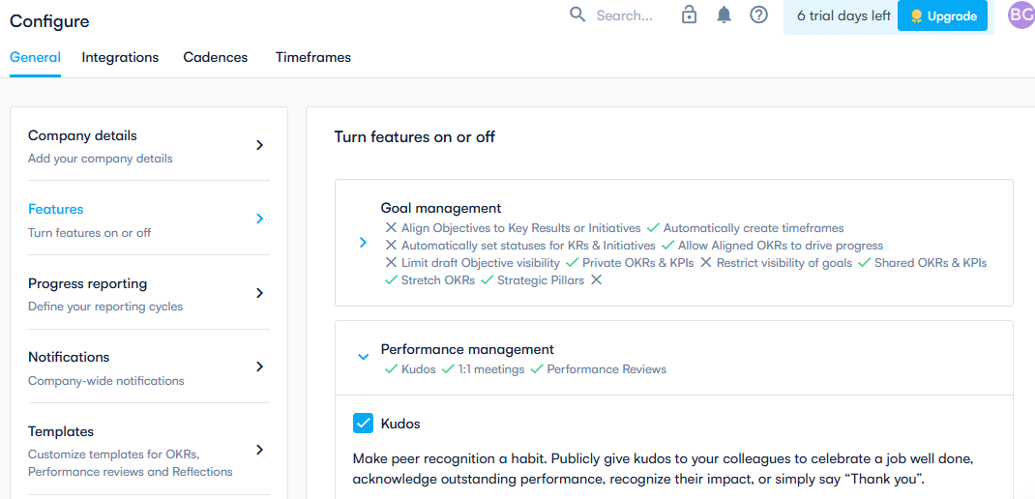

1. **Where to send Kudos from**

You can send Kudos from:

-Bottom of the Home Screen

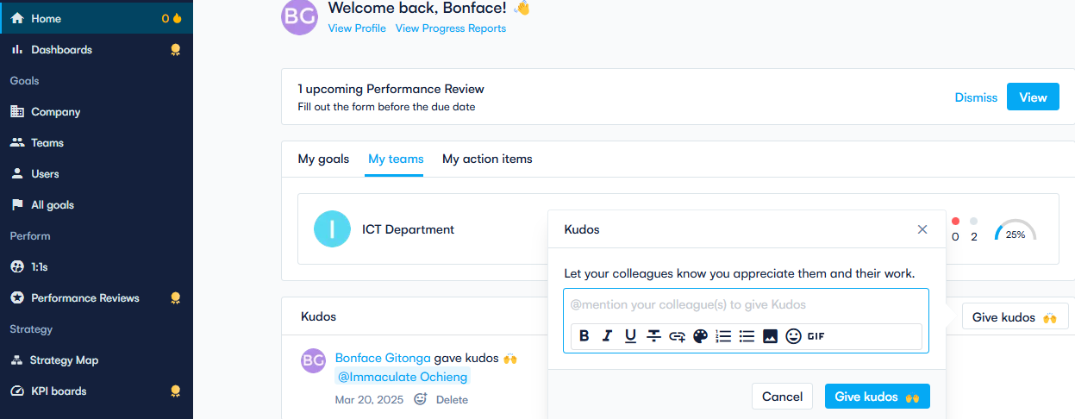

-From a user Profile

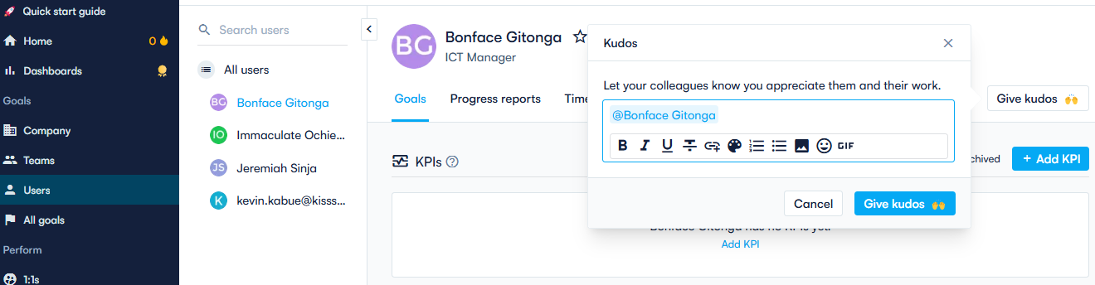

**NB**

* In order to send Kudos you must mention at least one person. You can also mention multiple people.
* Recipients will be notified via email when you submit your Kudos.
* If you wish to disable Kudos, you can do so from configure menu.(same as enabling it)

**8. Dashboards and Widgets**

These features provide teams with real-time insights into their goals and progress.​

**Custom Dashboards:**

Custom Dashboards empower users to create personalized views by combining information from various sources using widgets. This functionality allows teams to tailor dashboards to their specific needs, facilitating a focused approach to goal tracking. ​

**Widgets:**

Widgets are the building blocks of the dashboards, enabling users to display diverse data points and visualizations. By adding and arranging widgets, teams can monitor key metrics, track OKR progress, and highlight critical information. The platform should supports various integrations, allowing data from tools like Slack, Jira, and Google Sheets to be incorporated into dashboard

**Benefits:**

* **Enhanced Focus:** Custom dashboards help teams concentrate on their most important goals by providing a clear, visual representation of progress.​
* **Real-Time Insights:** Widgets offer up-to-date data, enabling timely decision-making and adjustments.​
* **Improved Accountability:** Transparent tracking fosters a sense of responsibility and encourages regular updates from team members.

a) Add a menu on the home page under reports and call it custom dashboards



Custom Dashboard

**a) Creating and Customizing Dashboards for individual teams and Executive team**

To build a new dashboard

Navigate to the Reports –Custom Dashboards section of your workspace

1. Click on "Create dashboard

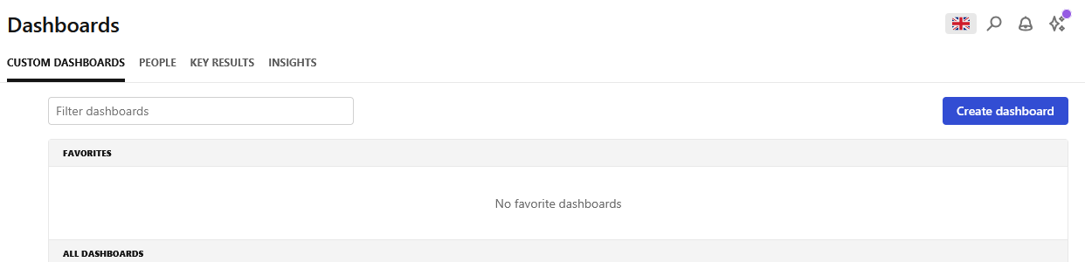

1. Enter the dashboard name and click create which redirect you to the add widget page

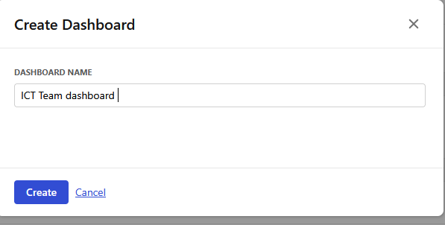

1. Click on add widget to add the desired widgets to tailor the dashboard to your requirements.

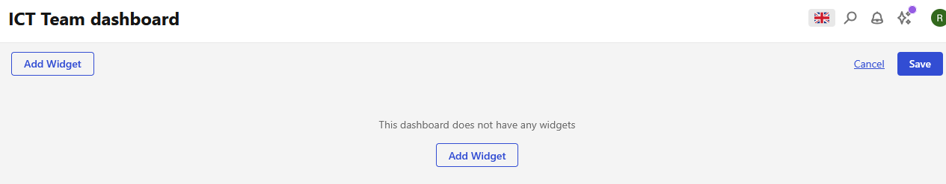

1. Add a Widget

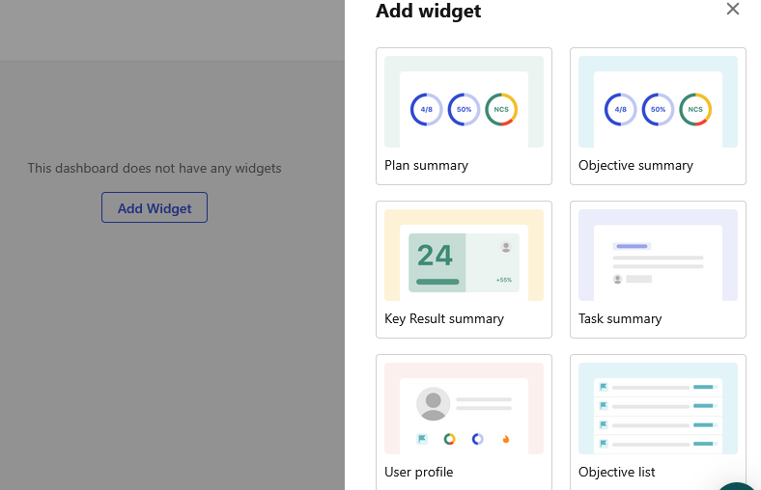

1. Enter the Widget title, select the desired plan e.g. 2025 MSR and the Objective/key result you want to visualize key metrics

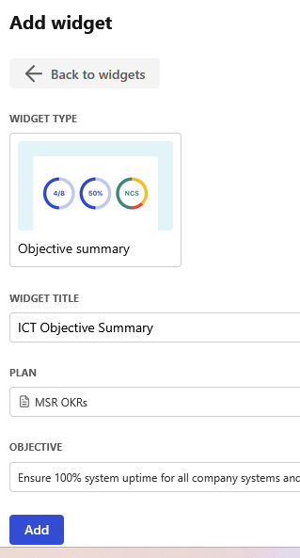

1. Once created, dashboards can be customized by resizing and rearranging widgets to prioritize information effectively. As shown below

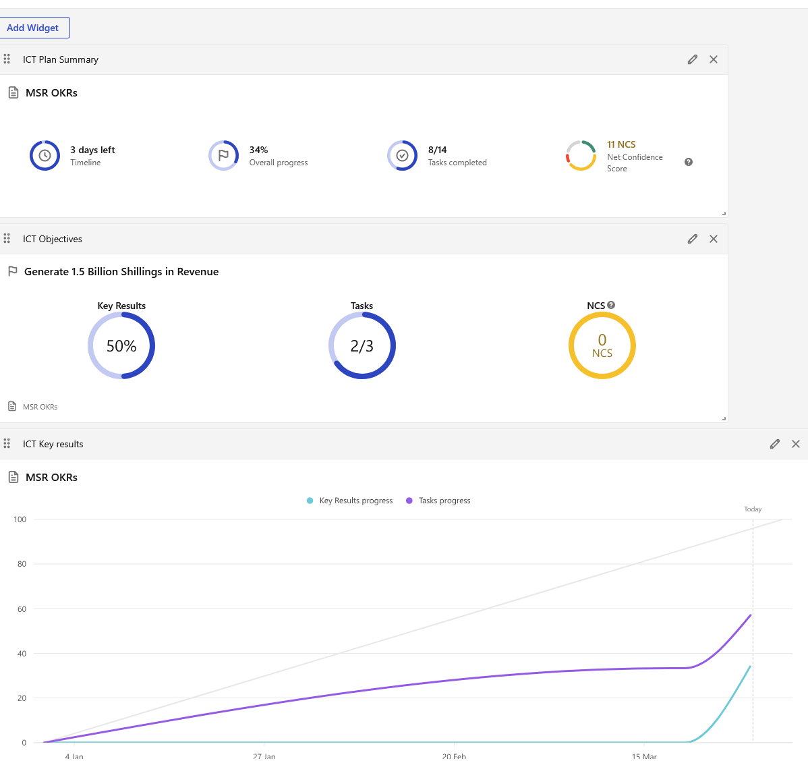

Save

1. Click Save to save the dashboard

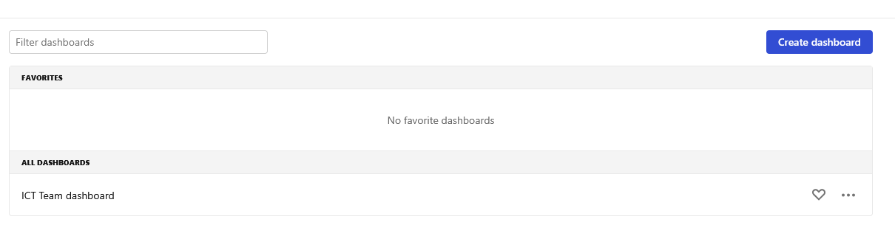

1. Once a user navigates to custom dashboard they will be able to view by click on the name to open the new dashboard

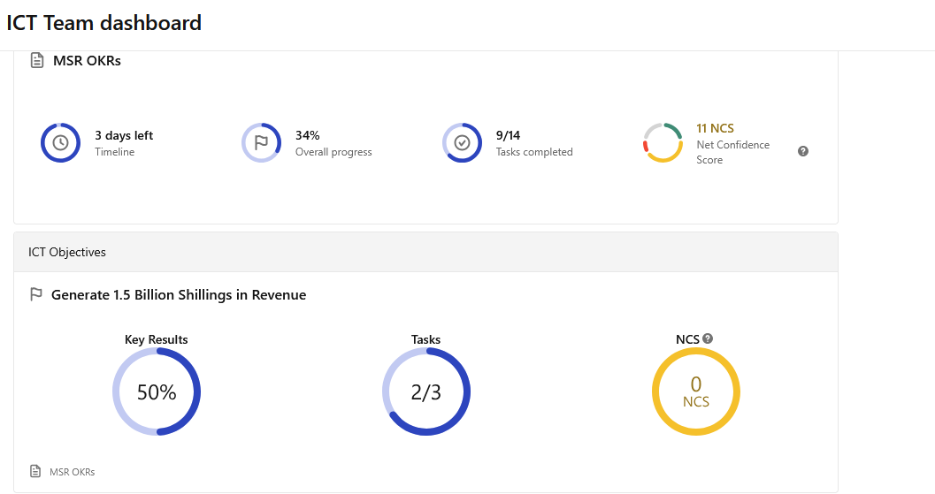

**b) Leadership Dashboard under custom dashboards (Available to Executive Team)**

1. Under custom dashboards add **Activity Dashboard** to simulate below metrics



1. 2.Add a Key results Dashboard to visualize a key results dashboard as shown below



1. Add an Insight’s dashboard to visualize insights as shown below

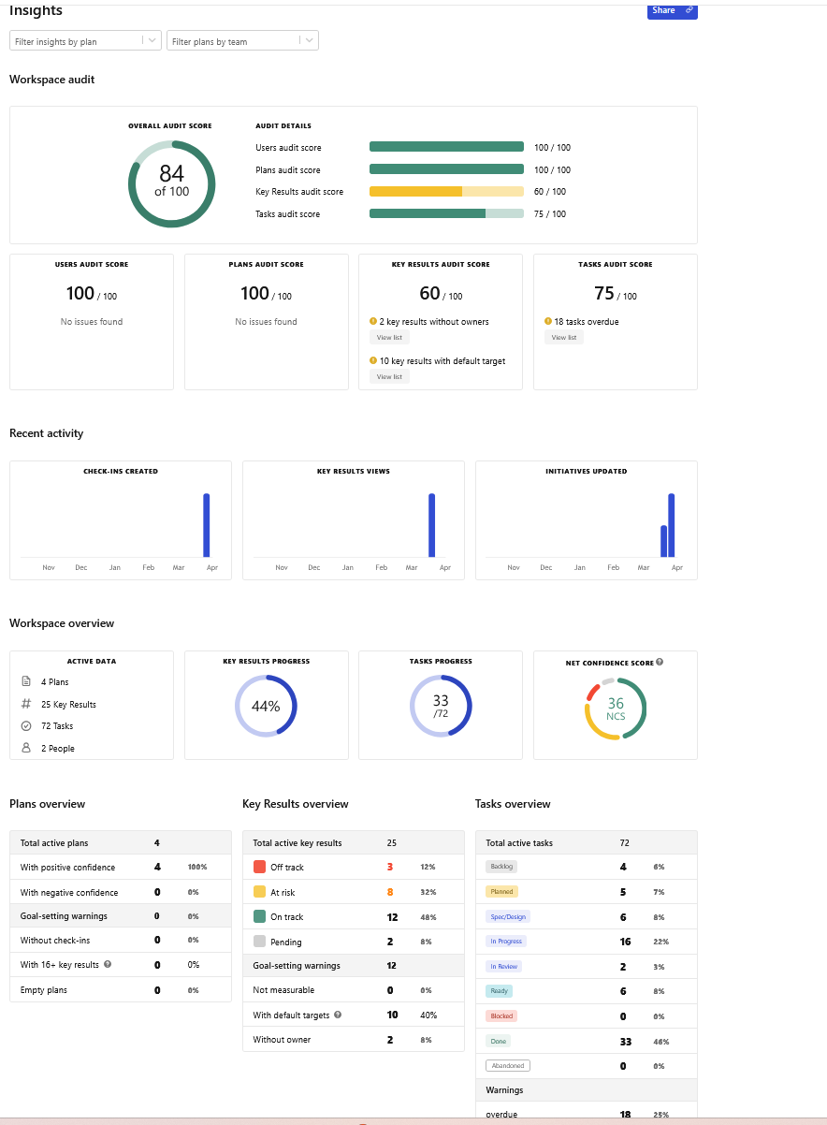

**9. Reports Export and Presentation Option**

Exporting reports from advanced OKR dashboards enhances your organization's ability to analyze performance, share insights, and maintain comprehensive records.

Below are general guidelines and examples we can use:​

**Export and Present Features**

* Dashboard Interface: Navigate to the reporting section
* Add filters at the top of the page to show Timeframe, Teams, and Detailed.​
* Export Formats**:** include Excel (.xlsx), CSV (.csv), and PowerPoint
* Present Team dashboard-Presents the teams Mission in PowerPoint format

**Power Point** Reports should generate presentation-ready slides showcasing your OKR progress and achievements.

May Include:

* Executive summary
* Visual progress indicators
* Key achievements highlights
* Next quarter planning
* Present Team Dashboard

-Key reports Export options and presentation sample view



-OKR Usage Export reports sample

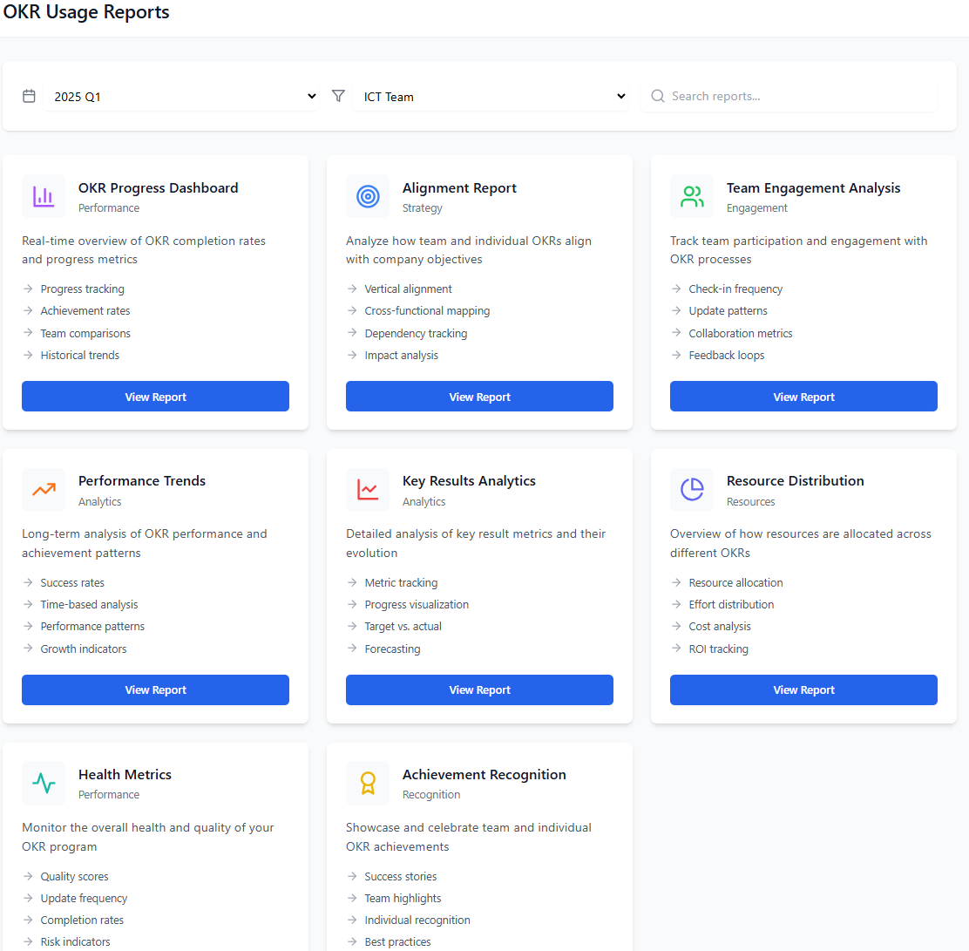

**10. AI and plugins Integrations**

Feature helps organizations seamlessly connect their OKR tracking with other tools. These integrations enhance productivity, automate updates, and ensure that teams stay aligned without switching between platforms.

### **Key Integration Features & Benefits**

### **Data Automation & Sync**

* **Automatically update OKRs** by linking them to real-time data from external sources.
* Reduce manual data entry and ensure that progress tracking is always accurate.
* Eliminate errors by pulling key metrics directly from business tools.

### **Native Integrations -**Built-in integrations with popular tools, including:

* **Slack & Microsoft Teams** – Receive OKR updates, check-ins, and notifications directly within your communication platform.
* **Google Sheets** – Sync key results with live spreadsheet data for automatic progress updates.
* **Jira** – Align software development teams with business objectives by linking Jira issues to OKRs.
* **Asana & Trello** – Connect OKRs with tasks and projects to track execution seamlessly.

### **API for Custom Integrations**

* Businesses can integrate the OKR system with **internal dashboards, CRMs, or databases** via API.
* Enables advanced automation and reporting tailored to unique workflows.
* Supports pushing and pulling OKR-related data programmatically.

### **Single Sign-On (SSO) & Security Integrations**

* **SSO support** via Google, Microsoft, and other identity providers for secure, streamlined access.
* Ensures compliance with enterprise security standards.

-Under configurations menu add Integrations as shown below which will be used to manage third-party integrations

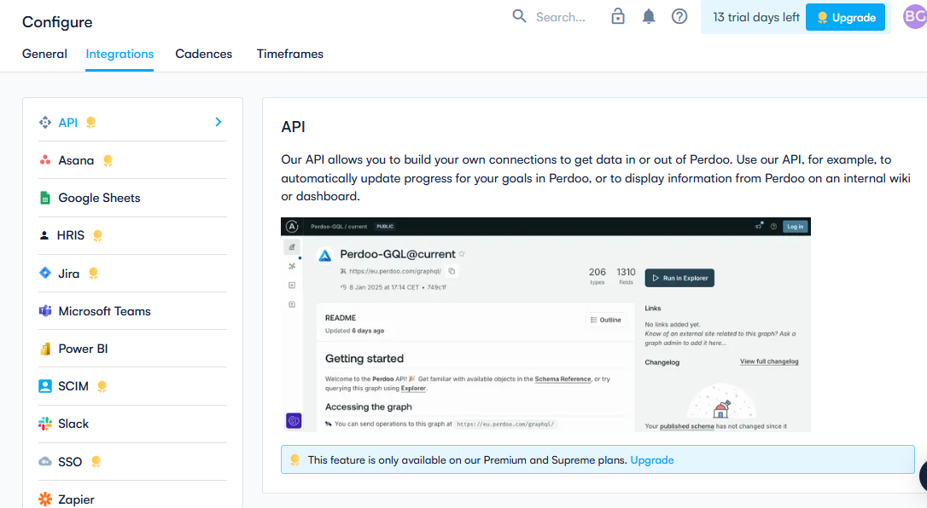

**11. Drag-and-Drop Feature**

Feature will, includes a drag-and-drop feature to make goal management more intuitive. This allows users to reorder OKRs, move tasks, and restructure goal hierarchies easily.

Application of Drag-and-Drop Works in

1. Reordering OKRs

You can drag an objective or key result to change its position within a list. This helps prioritize goals and improve visibility.

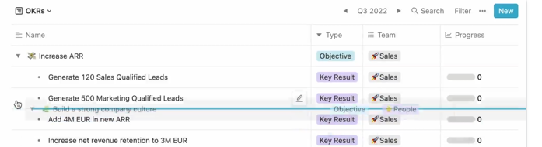

1. Moving OKRs Between Groups

If you use nested OKRs (objectives with sub-objectives or key results), you can drag them to different parent objectives this allows for easy restructuring of goals and objectives.

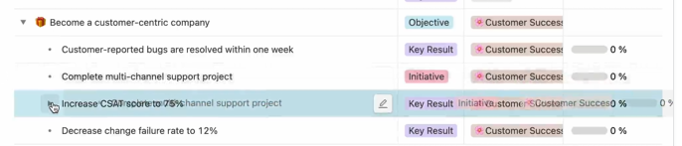

1. Adjusting Initiatives within Objectives/goals

\

-When tracking action items within an objective, drag tasks to reorder based on priority.

1. Dragging Items in Other Views (e.g., Kanban)

-Allow Drag and drop on Kanban-style boards, to ensure users can drag objectives or tasks between columns, representing different statuses.

**12. Get Started Video and Explore options Features**

**-** Add a Get started menu on top of the landing page

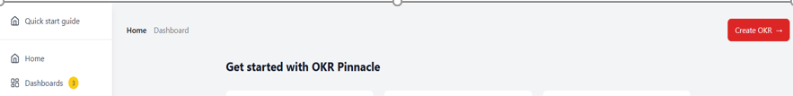

b) Once a user logs in for the first time pop up the Introduction video

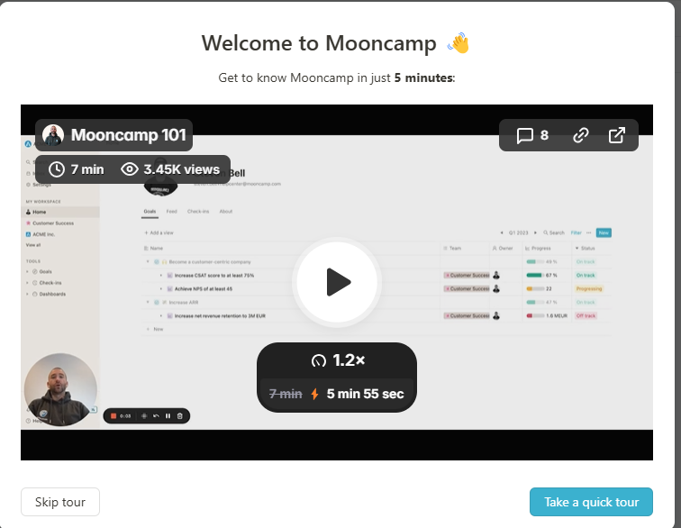

Welcome to Pinnacle OKR

Take a 10 Minute Introduction Video

1. Once a user is done with the video pop up the explore walkthrough option and guide the users on all the sections of the OKR system as shown on below sample walkthrough



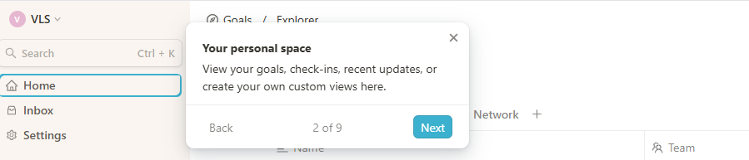

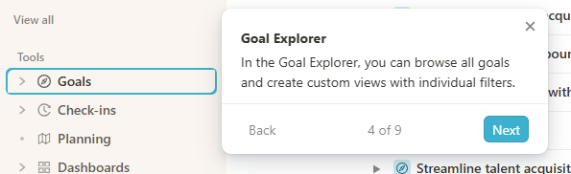

1. In app On boarding View and percentage view –Add resource view page to help users view and review there on boarding status and progress as shown on below sample

